Arts Merri-bek Strategy
  - 2023-2030
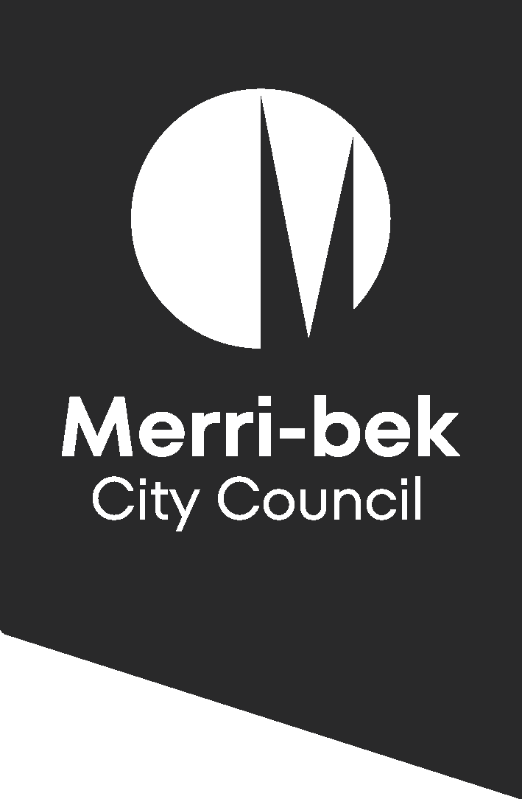

VISION

Merri-bek – where creativity and culture thrive.
The Arts and Culture Strategy speaks to the identity, ambitions and passions of the Merri-bek community, a place where arts, culture and creative expression are valued.
Diversity, equity and inclusion drives everything we do; arts and culture is our platform to create social change, beautify our area, delight and connect our community. We prioritise:
- First Nations artists and audiences, in line with our Statement of Commitment;
- Opportunities for Aboriginal and Torres Strait Islander communities, migrant and refugee communities, people with disability, women, LGBTIQA+ people, young people and older people.
- Collaboration with the community and across Council; and
- Advocacy for artists as workers
‘Big, bright and bold! I'd love to have Merri-Bek renowned for its support of the arts and culture. More funding, more events, more public spaces accessible for events.’
Community engagement participant
‘Cross-cultural and cross-generational inclusiveness. Use arts to make Merri-bek the foremost arts precinct in Melbourne.’
Community engagement participant

CONTEXT
Arts and cultural programming plays an important role in communities by:
- creating opportunities for self-expression and participation;
- building a sense of belonging and connection;
- increasing participation in civic life and combatting loneliness; and
- making the city more liveable.
Arts and culture beautifies the city and creates opportunities for celebration, from murals to building design to festivals. It has a significant economic impact, bringing customers to local businesses and providing employment.
What we mean by arts and culture: Visual arts, Cultural sites, Traditional cultural expression, performing arts, audio visual, new media, creative services, design, publishing, print media
What we mean by engaging with arts and culture: Attending events and venues, creating something, performing something, engaging with arts, culture and creative content in your home.
98% of Australians engage with arts and culture every day
82.4% of Australians attend cultural venues and events, and around a third create or produce art themselves
Merri-bek is renowned for its thriving arts sector and creative industries. They attract residents and visitors and play a significant part in Merri-bek’s economy, contributing $935 million to local output, generating $423 million in the region and supporting 4,340 jobs. Over 9,300 residents or 9.3% of our resident base worked in the sector, well above the Melbourne average of 7.9%.
Brunswick is home to a significant number of artist studios, artist-run galleries and artist-led initiatives and has a thriving design industry. Brunswick also has the largest population of songwriters in the country, and Coburg has the sixth largest.³ Live music venues are prevalent in the south and centre of the municipality. Coburg North industrial areas are thriving with pockets of artists' studios and event spaces and there is an increasing demand for opportunities for creation and presentation in the North of the municipality.
The Merri-bek community is socio-economically diverse, so while our creative community is thriving in the south, we must also recognise that access to arts and culture is often connected to location and socioeconomic background⁴. Those with lower incomes and reduced access to information are less likely to participate in arts activity. The Arts and Culture Strategy addresses equity at its core to ensure that everyone in Merri-bek can participate in arts and cultural activities.
The Merri-bek community is young and diverse: 37.1% were born overseas, 29.1% of households use a language other than English, the median age is 35 and close to a third of the population is aged between 25 and 39.
Hadfield/Glenroy/Fawkner 73-84% of suburbs across the nation have more socio-economic advantage. East Brunswick, 87% of suburbs have less socio-economic advantage.

Arts and Culture at Merri-bek Council
Merri-bek City Council arts and culture program:
- Festivals – community-engaged events Fawkner Festa, Glenroy Festival and Carols by the Lake, events that encourage economic stimulation and visitation like Sydney Road Street Party and Coburg Night Market and major events like Brunswick Music Festival;
- Counihan Gallery in Brunswick – a year-round exhibition program curated from an expression of interest process, which champions political and social justice issues;
- Public Art – commissioning new public artwork for Council’s building, open space and streetscape developments and temporary public art programming;
- Professional Development for artists;
- Grants – small grant program for the creation of new artwork and sector support for organisations and individuals;
- Counihan Gallery Strategic Plan and the Arts Merri-bek Disability Access and Inclusion Plans form an integral part of the Arts Merri-bek Arts and Culture Strategy.
Government investment (non-COVID related) in the arts in 2020/2021 in Australia: federal government contributed 38%, state and territory governments on average 37% and local governments 25%.
Government investment in the arts 2019/2020 in Victoria: In Victoria in 2019/2020, local governments contributed just under 50% of the total government cultural expenditure

Designing the strategy
Over 200 people participated in the design of the strategy through an online survey and face-to-face consultations. We also engaged directly with Merri-bek’s Arts Advisory Committee, First Nations Creative Consultation group and Children’s Reference Group.
Responses were positive, aspirational and hopeful. We heard that our community:
- is passionate about Merri-bek and want to see more artists and more activity everywhere;
- is proud of the arts community and want to see Merri-bek identified as the leader of arts and culture across Melbourne and Victoria; and
- see the arts as a vibrant force for community cohesion and core to the celebration of diversity.

KEY PRIORITIES AND COMMITMENTS
The needs and ideas that we heard through this extensive consultation have directly informed the development of this strategy, and its key priority areas – investment, creation and connection.
The 2023-2030 Arts Merri-bek Strategy will be supported by annual action plans, and with the aim to deliver on five key commitments and source additional resourcing as required.
Holding our vision and values at the centre, we will deliver through three priority areas to achieve strong social, environmental and economic outcomes for the Merri-bek community.

Priorities
Creation – a city that champions arts and cultural activity that is self-determined, intersectional, intergenerational, accessible and available across the municipality.
Connection – a city that foster connections between artists, audiences and community.
Investment – a city that invests in the creative community and generates opportunities for artists and the creative sector.

Commitments
- Increased employment for First Nations artists;
- Increased arts and cultural programming and creative spaces in the North of the municipality;
- A refreshed festival program that is flexible, innovative, and more accessible across the municipality;
- Increased access to spaces and funding for artists and creatives to make, collaborate and present work; and
- Public art to be built into Council capital works, urban design and open space projects.

CREATION
We will champion arts and cultural activity that is self-determined, intersectional, intergenerational, accessible and available across the municipality.
Arts Merri-bek is renowned for presenting a diverse and dynamic festival program, the Counihan Gallery in Brunswick and its public art and street art offerings. These programs have increasingly focused on supporting artists from the Merri-bek Human Rights Policy priority groups to create and present work across the municipality.
Our next step is to work with artists and community to ensure self-determination and intersectionality across our program. Recently we have worked with a pilot First Nations Creative Consultation group to create self-determined programming opportunities and will expand on this work with Merri-bek’s First Nations creative community into the future.
With artistic excellence at their core, we will ensure our programs offer intergenerational opportunities for both artists and audiences and supports diverse artists at all stages of their careers.
Through our Arts Merri-bek Disability Access and Inclusion Plan we will increase the accessibility of our programs through working with disabled artists, consultants and staff on programming, event design, access needs and marketing.
Our festival program will be refreshed to remain responsive to community need and to ensure that opportunities to engage with events and the arts are offered equitably across the municipality.
We will ensure that arts, culture and creativity is integrated into the way we work across all areas at Council. This will improve public amenity and civic pride, create employment opportunities for our artists and firmly establish Merri-bek as a leading municipality for the arts.

CONNECTION
We will foster connections between artists, audiences and community.
We are committed to connecting audiences with the work of the Merri-bek creative community, and to increasing access to arts programs and events locally. We aim for audiences to reflect the diversity of municipality.
In recent years we have grown the Arts Merri-bek brand and social media presence significantly, however through the community engagement process we regularly heard that people didn’t know what was on in the municipality or how to engage with our programs.
We will investigate platforms and pathways to better promote local events and activities to our diverse audiences and seek opportunities to connect artists with audiences directly.
We also heard frequently from artists and organisations wanting to connect with each other. We will take a lead role in enabling industry networking and community-building to contribute to a thriving sector. We also want to create long-term opportunities for artists within the Merri-bek community through supported residencies and fellowships.

INVESTMENT
We will invest in the creative community and generate opportunities for artists and the creative sector.
Strong investment in arts, culture and the creative sector is vital to ensure Merri-bek maintains and grows its creative neighbourhoods for future generations. We have a large creative population and want to support them to remain living and working in Merri-bek despite the challenges of city growth and gentrification. Keeping our artists here not only keeps them connected to community, but also creates a flourishing and vibrant city for both residents and visitors alike. It drives economic development and tourism, building on Merri-bek’s already excellent reputation for live music and the arts.
There is a significant unmet demand for affordable, flexible creative spaces across the municipality. The strategy aims to support the sector’s need and will activate more spaces to create and present work, including studio and rehearsal spaces, performance spaces and galleries. Council’s redevelopment of 33 Saxon Street into a cultural and community hub will offer significant opportunities for artists and the creative industries to work and play close to home.
Through grants and professional development programs, Council invests in artists to develop new works locally for presentation within Merri-bek, Melbourne, Australia and around the world. This investment provides sustainable funding for artists and organisations, promotes community connection and is responsive to the long- and short-term needs of the sector. Improving the accessibility of EOI and application processes, and cutting red tape, will open up our investment opportunities more broadly, particularly to those from marginalised communities.
We also seek to grow investment in artists by commissioning public art and through the Merri-bek Art Collection, ensuring that artists contribute to the vibrancy of new and refreshed community buildings and spaces.

ARTS AND CULTURE STRATEGY ACTION PLAN YEAR 1 & 2 – 2023/2024 and 2024/2025

CREATION
A city that champions arts and cultural activity that is self-determined, intersectional, intergenerational, accessible and available across the municipality.
Ref. | Key Actions | Delivery | Resources | Partners
1.1 | Increased opportunities for First Nations programming. | 2023/2024 | Within current resources | First Nations Creative Consultation Group, First Nations Reference Group, Wurundjeri Council, Community Development
1.2 | Review of accessibility of event permit processes and fees. | 2023/2024 | Within current resources | First Nations creative consultation group, community organisations, Community Development, Open Space
1.3 | First Nations designated role in Arts and Culture to participate in festival and gallery programming and grant and professional development program design and execution. | 2024/2025 | Additional resources required | First Nations Creative Consultation Group, First Nations Employment Officer
1.4 | Design and delivery of updated festival program that is flexible, innovative and more accessible across the municipality. Accessibility to include economic accessibility such as more affordable food options. | 2023/2024 (Design)  2024/2025-ongoing  (Delivery) | Within current resources | Arts Advisory Committee
1.5 | Initiate annual Merri-bek Art Collection exhibition in the North of the municipality. | 2024/2025 | Additional resources required | Community organisations and/or Council venues
1.6 | Increased involvement from children and young people in festival and gallery programs. | 2024/2025 | Within current resources | Schools, Children’s Services and Youth Services
1.7 | Increased participation opportunities for LGBTIQA+ communities in Council arts and cultural programs. | Ongoing | Within current resources | Community Development and Social Policy
1.8 | Collaborate across Council and build internal networks for increased community impact from arts-based projects and to ensure arts and cultural programming is used to support Council policies and to champion social issues. | Ongoing | Within current resources | Places, Libraries, Youth Services, Community Development, Sustainable Environments
1.9 | Arts Merri-bek Disability Access and Inclusion Plan actions | Ongoing | Within current resources | Disability Reference Group

CONNECTION
A city that connects artists, audiences and participants.
Ref. | Key Actions | Delivery | Resources | Partners
2.1 | Work with Community Development team to create a relationship development plan for the North of the municipality, with the aim of building sustained and long-lasting relationships with organisations and communities. | 2023/2024 | Within current resources | Community Development, Glenroy Community Hub, Neighbourhood Houses
2.2 | Investigate ways to better promote non-Council arts activity across Merri-bek and create guide for artists. | 2023/2024 | Within current resources | Communications
2.3 | Increase the profile of public art across the municipality through mapping and online access to the public art and Merri-bek Art collections. | 2023/2024 | Within current resources | Communications
2.4 | Deliver visitor engagement plan for Counihan Gallery. | 2023/2024 | Within current resources
2.5 | Continuation of First Nations Creative Consultation group. | Ongoing | Within current resources
2.6 | Research and creation of an internal Merri-bek artists directory and create pathways for artists to better connect with Council | Ongoing | Within current resources | Local artists and creatives
2.7 | Design and deliver networking/connection program for local arts community. | Ongoing | Within current resources | Local artists and creatives
2.8 | Develop and deliver external communications plan for Arts Merri-bek programs. | Ongoing | Within current resources | Communications
2.9 | Continue to support and promote live music venues through programming and networking opportunities. | Ongoing | Within current resources | Live music venues
2.10 | Arts Merri-bek Disability Access and Inclusion Plan actions | Ongoing | Within current resources | Disability Reference Group

INVESTMENT
A city that invests in the creative community and creates opportunities for artists and the creative sector.
Ref. | Key Actions | Delivery | Resources | Partners
3.1 | Develop business case for First Nations Artists Fellowship. | 2023/2024 | Within current resources, additional resources required to proceed in the future | First Nations Creative Consultation group
3.2 | Develop new Public Art Policy including percentage for public art in Council capital budgets and process for increasing maintenance budget. | 2023/2024 | Within current resources, additional resources required to proceed in the future | Capital Works, Open Space, Urban Design, Place Revitalisation, Project Management Office
3.3 | Offer not-for-profit rates to artists for Council venues | 2023/2024 | Within current resources | Community Venues, Facilities
3.4 | Support the development of the creative and community hub at 33 Saxon Street | 2023/2024 | Within current resources | Place Revitalisation
3.5 | Coburg Courthouse to become a venue for creative development. | 2023/2024 | Within current resources | Community Venues
3.6 | Honorarium allocated to all Counihan Gallery in Brunswick exhibiting artists. | 2023/2024 | Within current resources
3.7 | Develop new Merri-bek Art Collection Policy | 2023/2024 | Within current resources
3.8 | Establish Public Art maintenance budget to support recent acquisitions. | 2024/2025 | Additional resources required | Capital Works
3.9 | Redesign and staged roll out of more impactful and accessible arts grant program with increased budget to respond to community-identified needs and to attract organisations to the municipality. | 2024/2025 | Additional resources required over multiple years
3.10 | Broker opportunities for creative uses of under-utilised Council-owned buildings and other developments. | 2024/2025 | Within current resources | Property, Places, Community Venues, Facilities
3.11 | Commencement of planning for arts centre in the North of the municipality. | 2024/2025 | Within current resources | Libraries, Capital works
3.12 | Scope artist in residence program. | 2024/2025 | Within current resources, additional resources required to proceed in the future | Schools, aged-care, other partners
3.13 | Continue creative places activation through contract management of Brunswick Mechanics Institute, Schoolhouse Studios, Coburg Courtyard and 33 Saxon Street | Ongoing | Within current resources | Place Revitalisation and Activation
3.14 | Ensure artist professional development program responds to needs of the creative community, is accessible online and includes the North of the municipality. | Ongoing | Within current resources
3.15 | Arts Merri-bek Disability Access and Inclusion Plan actions | Ongoing | Within current resources | Disability Reference Group
3.16 | Support creative neighbourhoods’ initiatives including Brunswick Design District, Vibrant Brunswick, Coburg North industrial precinct, live music precinct. | Ongoing | Within current resources | Economic development, Strategic planning, Planning, Places

2021-2031 Merri-bek Community Vision: Merri-bek is our home. We respect and look after our land, air, waterways and animals. We care for our people and celebrate our diverse stories, cultures and identities. Merri-bek is enhanced by all of us supporting our local businesses, arts communities and social organisations. We work together proactively and transparently to continue to create a vibrant, safe, healthy, resilient, innovative and regenerative community.
Reconciliation (merri-bek.vic.gov.au)
A New Approach, 2020, ‘Society and place: Transformative impacts of arts, culture and creativity’ [Factsheet 1]. Produced by A New Approach think tank with lead delivery partner the Australian Academy of the Humanities, Canberra
Fielding, K., Trembath, J.L., February 2022. “The Big Picture 2: Public Expenditure on Artistic, Cultural and Creative activity in Australia in 2007-08 to 2019-20”. Insight report no. 2022-01. Produced by A New Approach (ANA). Canberra, Australia. Page 49
Fielding, K., Trembath, J.L., February 2022. “The Big Picture 2: Public Expenditure on Artistic, Cultural and Creative activity in Australia in 2007-08 to 2019-20”. Insight report no. 2022-01. Produced by A New Approach (ANA). Canberra, Australia. Page 48
Creating our Future, Results of the National Arts Participation Survey August 2020, Australia Council. Page 10
A New Approach, 2020, ‘A rich cultural life: Transformative impacts of arts, culture and creativity’ [Factsheet 7]. Produced by A New Approach think tank with lead delivery partner the Australian Academy of the Humanities, Canberra.
2016 Australian Bureau of Statistics Census data and NIEIR data.
2021 Moreland, Census All persons QuickStats | Australian Bureau of Statistics (abs.gov.au)
SEIFA by profile area | City of Merri-bek | Community profile (id.com.au)
Vivian, A., Fielding, K., Acker, T., March 2023. “The Big Picture 3: Expenditure on Artistic, Cultural and Creative activity by governments in Australia in 2007–08 to 2020–21”. Insight report no. 2023-01. Produced by A New Approach (ANA). Canberra, Australia. Page 35
Fielding, K., Trembath, J.L., February 2022. “The Big Picture 2: Public Expenditure on Artistic, Cultural and Creative activity in Australia in 2007-08 to 2019-20”. Insight report no. 2022-01. Produced by A New Approach (ANA). Canberra, Australia. Page 31

