Draft Climate Risk Strategy

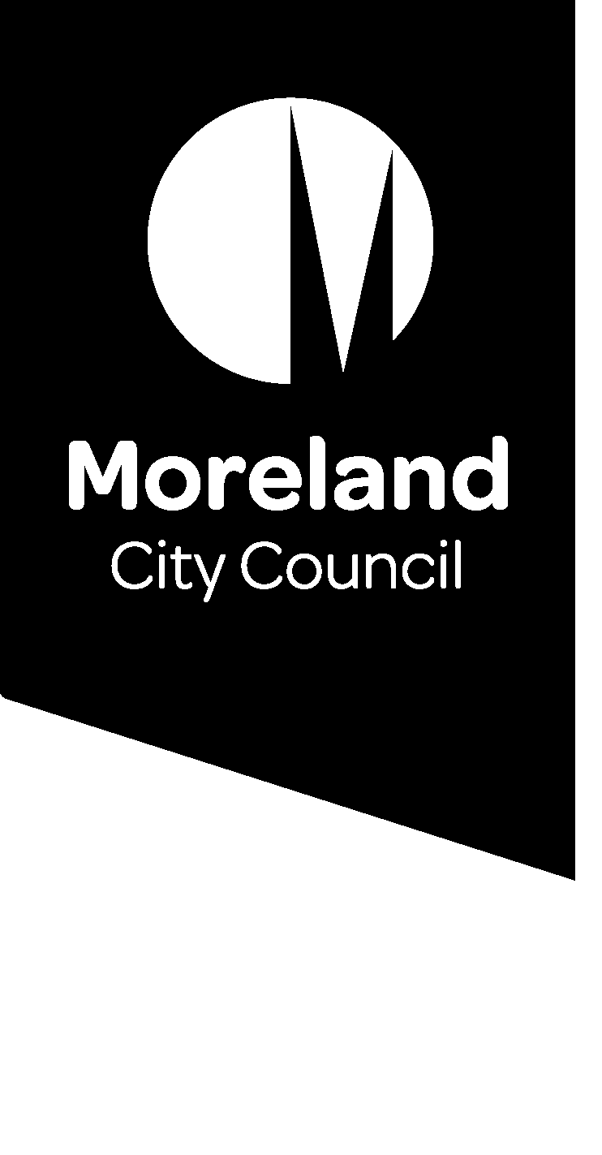

(Draft) Climate Risk Strategy

**The Climate Risk Strategy (the Strategy) describes how Council will proactively plan for and respond to the inevitable impacts of climate change.**

**Our Vision is that, by 2040:  
 - Council competently, accountably and responsively manages climate risk, and  
 - Moreland is climate-resilient, leafy and liveable; with  
 - A climate-ready and resilient community.**

The Strategy describes Council’s integrated approach to:

* Managing climate-related risks to Council, its assets and the services it provides.
* Adapting Council’s infrastructure, open spaces, natural environments and community services to climate change, while also supporting the Moreland community’s adaptation journey.
* Building resilience within Council and across the municipality.

Why do we need a Climate Risk Strategy?

Council is committed to reducing the greenhouse gas emissions that cause climate change while supporting the Moreland community in adapting to its now unavoidable impacts. These impacts are already being felt in Moreland and will worsen over the coming decades (Figure 1). They include hotter and drier conditions, with rarer and more extreme rainfall events. Extreme heat will be amplified by the Urban Heat Island Effect, and summers will become more challenging as dust and bushfires impact air quality.

Figure 1 Climate change projections for Victoria, DELWP 2019

Climate will increasingly impact on Council services. High heat days and extreme rainfall events are already impacting when it is safe for Council officers to work outdoors or conduct in-home care visits. Maintaining and growing natural green spaces is challenging in a hotter and drier climate, and drainage infrastructure has difficulty coping with increasingly extreme rainfall events.

Meanwhile, the demand on Council services will change and increase because of climate change. Climate change increases community vulnerability and will significantly impact on vulnerable cohorts. For instance, extreme heat is associated with poor outcomes for infants and the elderly, as well as increases in family violence.

Climate change also creates risks for Council. It poses financial risks through the cost of adapting to a changed climate and of remediating the impacts of extreme events. Insurers are beginning to factor climate change into premiums and are limiting their coverage of significant risks. Governments are also increasingly exposed to legal action for failing to proactively adapt to climate change.

Early action is necessary to manage climate impacts and continue providing quality public services.

* **Climate risk** is the potential for adverse consequences to human or ecological systems from climate impacts.
* Climate change **adaptation** involves action to reduce the adverse consequences of climate change or to harness opportunities.
* **Resilience** is the ability to avoid, withstand, and recover from climate impacts, and ‘bounce forward’ to a better adapted state.

Early action also has significant financial and social benefits. Deliberate adaptation saves money by avoiding large risks, rather than bearing the cost of remediating impacts and retrofitting adaptation responses. It also supports social cohesion, equity and wellbeing by reducing vulnerability and fostering opportunity.

What we already do

Council is already responding to climate change through a range of work programs. This Strategy will not duplicate this work. Rather, it is designed to build on it to comprehensively manage Council’s climate risk.

Action is already underway to reduce greenhouse gas emissions through Zero Carbon Moreland, including increasing environmentally sustainable design through the Moreland Planning Scheme. Council is also working to adapt and build resilience to climate change, including through:

* **Creating more resilient landscapes and healthy waterways** through stormwater harvesting ad projects like Moomba Park Wetland (Integrated Water Management Strategy and The Nature Plan).
* Purchase of land and **creating of new green spaces and local parks** in areas of Moreland without parks in walking distance (Park Close to Home).
* **Increasing canopy cover through tree planting** in streets, parks and gardens (Urban Forestry Strategy).
* **Improving the wellbeing and energy security of low-income residents** through grants and support for home insulation/draught-proofing or rooftop solar.
* Council’s **planning and response to emergency events**, including severe weather driven by climate change (Municipal Emergency Management Plan and sub-plans).

Our commitments and obligations

Council has climate change roles and responsibilities under Victorian legislation. Moreland Council has also made proactive commitments that build on these legislated obligations.

* The [Climate Change Act 2017](https://www.climatechange.vic.gov.au/legislation/climate-change-act-2017) requires that decision-makers have regard to climate change.
* The [Local Government Act 2020](https://www.localgovernment.vic.gov.au/council-governance/local-government-act-2020) requires local governments to plan for climate change risks.

Council declared Climate Emergency on 12 September 2018. In doing so we acknowledged that climate change is a threat to us and our future, and we committed to urgent action.

In 2020, Council requested an independent audit of our climate adaptation action (Crowe, November 2020). This Audit found that while Moreland has a record of adaptation action, Council needs to better plan and coordinate its efforts. It recommended we develop a strategic approach to climate adaptation, risk and resilience, supported by a strong action plan.

Council drivers

The Strategy will work towards the [Community Vision](https://www.moreland.vic.gov.au/my-council/about-council/moreland-2021-31-community-vision/), in particular:

*Council and community working together proactively and transparently to continue to create a vibrant, safe, healthy, resilient, innovative, and regenerative community.*

It is also our delivery mechanism for [Council Plan](https://conversations.moreland.vic.gov.au/council-plan) Strategy 3.3, to:

*Strategically invest in Council’s community services and assets to increase our resilience and adapt to climate change risks and impacts that are now unavoidable (such as severe heatwaves, flash flooding, unreliable rainfall).*

And it contributes to achieving Strategic Objective 3, namely:

*To support Moreland to become a more inclusive, connected, healthy and caring community through providing equitable access to community facilities and services, facilitating local partnerships and programs, mitigating the effects of climate change and supporting the community to adapt and build climate resilience.*

The Strategy also supports achieving Council Plan Strategic Objective 1:

*To strive for maximum protection of people’s health, plants and animals through leading an urgent response to the climate emergency and a regeneration of our natural environment.*

Shared responsibility

Climate risk poses a huge challenge that is far beyond the resources and scope of any one local government. Climate change impacts us at national, State and regional levels. Interdependencies between these scales and levels of government mean that adaptation must be a shared responsibility.

The Federal Government’s [National Climate Resilience and Adaptation Strategy](https://www.awe.gov.au/science-research/climate-change/adaptation/strategy) 2021-2025 includes plans to:

* Drive investment and action through collaboration - The effective delivery of this objective is vital to support local government climate adaptation action.
* Improve climate information and services - Council depends on the CSIRO and Bureau of Meteorology to provide us with timely and locally relevant climate change projections to understand the type of future we must plan for.

The Victorian Government has also released [Victoria’s Climate Change Strategy](https://www.climatechange.vic.gov.au/victorias-climate-change-strategy), which outlines its adaptation priorities to 2025. Of these, action on sustainable adaptation finance is critical for local governments. The State Government is better placed to work with large insurers and financiers to address gaps in insurance coverage and develop approaches to finance adaptation action.

The State Government has developed regional adaptation strategies to support coordinated regional action. The [Regional Climate Change Adaptation Strategy for Greater Melbourne](https://engage.vic.gov.au/regional-climate-change-adaptation-strategy-greater-melbourne) outlines key priority action areas to guide local action to address the unique challenges and opportunities climate change creates for Greater Melbourne. Financial support is vital for local governments to effectively deliver the scale of practical activities necessary to implement the regional adaptation strategy.

The State Government has prepared Adaptation Action Plans for systems vulnerable to climate change impacts or essential to ensure Victoria is prepared. Council adaptation action will be informed by plans for the [Built Environment](https://engage.vic.gov.au/aaps-builtenvironment), [Health and Human Services](https://engage.vic.gov.au/aaps-healthandhumanservices), [Transport](https://engage.vic.gov.au/aaps-transport), [Natural Environment](https://engage.vic.gov.au/aaps-naturalenvironment), and the [Water Cycle](https://engage.vic.gov.au/aaps-watercycle).

The Strategy

The Climate Risk Strategy establishes a framework for Council to manage climate risk, drive adaptation action and build resilience. It envisages that by 2040, Council and community will be climate-ready and resilient. This Vision will be delivered through five Goals around:

1. Managing climate risk
2. Built and natural environments
3. Community services
4. Community and business
5. Partnership approaches.

The objectives under these Goals use the **hazard-exposure-vulnerability** model of climate risk (Figure 2) to deliver on outcomes. This approach helps understand the source of climate risk and proactively prioritise, prepare and plan for it.

* **Hazards** are potential natural or human-induced events, trends or physical impacts that might cause damage (e.g. loss of life, injury and other health impacts, as well as damage and loss to property, infrastructure, livelihoods, services and ecosystems)
* **Exposure** is the presence of things we value in places or settings that might be impacted by a hazard. These include people, livelihoods, species or ecosystems, environmental functions, services and resources, infrastructure, or economic, social, or cultural assets.
* **Vulnerability** describes how susceptible the things we value are to adverse impacts from hazards. It includes a variety of concepts including sensitivity and inability to cope and adapt.



Figure 2 Hazard-exposure-vulnerability model of climate risk (IPCC WGII AR5)

Using this approach supports Council in making decisions about how best to manage climate risk across a range of possible climate futures. This includes:

* A high physical risk scenario resulting in high mid and end-of-century temperature changes and associated impacts.
* A moderate physical risk scenario resulting in high mid-century but low end-of century temperature changes and physical impacts.

The future is uncertain, so climate change adaptation requires an iterative risk management process (Figure 3). The Strategy supports regularly reviewing changing climate risks and making best-value decisions to manage them.

The Goals establish ongoing iterative processes to:

* Gather data and scope risks
* Analyse and evaluate risks and options
* Implement and review projects
* Learn from implemented projects when planning future actions.

The iterative cycle of climate risk planning and review will be aligned to the 4-year Council planning cycle. Every 4 years, the Strategy and an associated Action Plan will be refreshed, informed by the Council Plan such that climate risks are managed in line with community expectations.



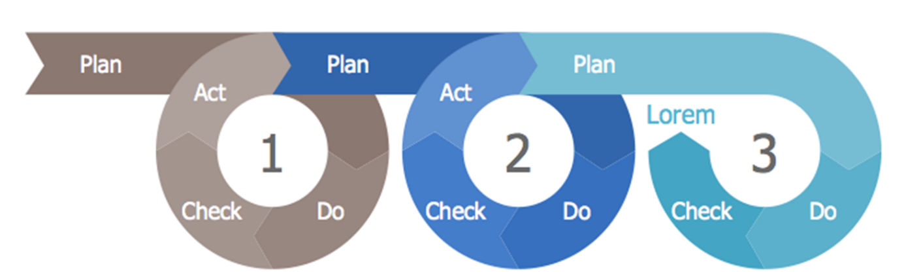

Figure 3 Managing climate risk is an iterative process (IPCC WGII AR5 and Deming E.W.)

The systems established through the Goals will also allow Council and community to use an adaptation pathways approach to consider and respond to ongoing climate risk (Figure 4). Adaptation pathways help develop and iterate plans for achieving the Vision, even in an uncertain future, by prioritising, preparing and planning for important decisions. This approach helps reduce unnecessary expenditure by focusing on the intended outcome and using appropriate information to make the most cost-effective decision each point in time.

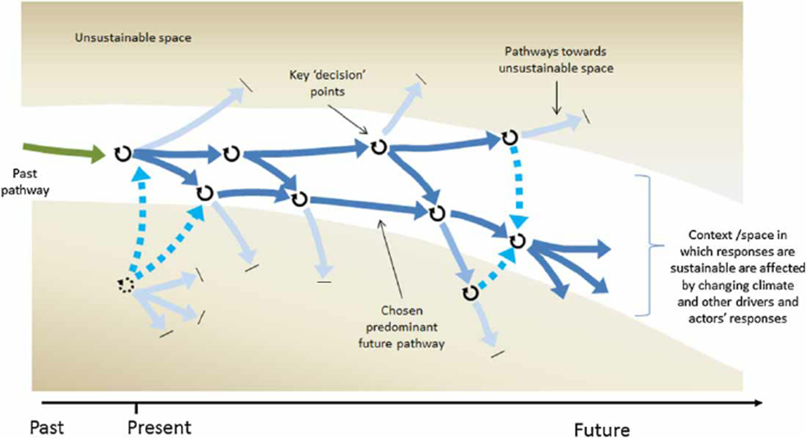

Figure 4 Adaptation pathways (Fazey et al, 2015)

Goal 1 – Managing climate risk

**By 2025, Council has iterative risk management, reporting and decision-making processes in place to proactively and accountably manage climate-related asset, service delivery, financial and liability risks.**

In order to effectively manage climate risk and deliver adaptation outcomes for Moreland, Council requires established, effective and best practice internal processes to understand the risk and integrate it into organisational decision-making. These systems are foundational to prioritising, identifying and planning action on climate change and so must be established prior to other Strategy actions commencing. Hence, this Goal will be delivered in full by 2025.

In line with the recommendations of the Taskforce on Climate-related Financial Disclosures (TCFD), it will establish processes to actively monitor and transparently report on climate risk. Council will also build capacity and capability to provide services under climate change through workforce training and planning systems.

|  |
| --- |
| OBJECTIVES and desired Outcomes |
| **1.1 To improve Council understanding of organisational and community climate change risk exposure and vulnerability, based on high-quality information on climate change hazards** |
| 1.1.1 Council officers have access to climate change scenarios, and locally relevant climate projections and data, to inform decision-making, asset design, service delivery, environmental management, risk and vulnerability assessment and monitoring. |
| 1.1.2 Council officers and decision-makers understand the likely range of possible future climate change impacts on the municipality, including sudden shocks and long-term stressors, and know how to use this information to appropriately inform decision-making. |
| 1.1.3 Council decision-making is informed by established tools and processes to regularly monitor, review and evaluate, the changing exposure and vulnerability of infrastructure, open spaces, natural environments, and community services, to:   * physical and structural risks associated with climate hazards, * risks to their functional performance as a result of climate change, and * transition and liability risks arising from Council’s response to climate change.   *Dependent on 1.1.1 and 1.1.2* |
| 1.1.4 Council officers and decision-makers understand and use appropriate data, tools and approaches, including climate change projections, scenario planning and business continuity planning, to understand how climate change is likely to impact the delivery of council services at different timescales, including:   * The ability of council to deliver the service, * The ability of the community to access the services, and * Increases or decreases in demand for services, or the need for entirely new services.   *Dependent on 1.1.1 and 1.1.2* |
| 1.1.5 Council monitors and understands the changing exposure and vulnerability of the Moreland community, residents and businesses (especially vulnerable cohorts) to the risks and impacts of climate change, regularly reviews this through established processes and forward scans for new and emerging risks.  *Related to 1.1.3* |
| **1.2 To make informed decisions on prioritising, preparing for and proactively addressing climate risk, driving climate adaptation and building resilience** |
| 1.2.1 Council design, delivery and management of its infrastructure, open spaces, natural environments and community services is informed by an understanding of the level of climate-related financial and liability risk it is willing to tolerate; Council actively limits the creation of future financial risk. |
| 1.2.2 Council has embedded clear and transparent tools for considering climate adaptation implications and trade-offs in decision-making across its infrastructure, open spaces, natural environments and service provision functions.  *Dependent on 1.1.4 and 1.2.1* |
| **1.3 To improve monitoring, reporting and evaluation of climate risks and adaptation action to better inform investment decisions and resource allocation** |
| 1.3.1 Council officers actively monitor and evaluate the outcomes of adaptation action against new and emerging climate risks to its infrastructure, open spaces, natural environments and community services. Council has embedded a culture of evaluation and learning which influences and informs climate change adaptation decision-making.  *Dependent on 1.1.3, 1.2.1 and 1.1.6* |
| 1.3.2 Council officers actively monitor climate adaptation support provided to residents and businesses, including through Zero Carbon Moreland Framework 2040, to ensure it is effectively mitigating and managing local climate change risks. |
| **1.4 To improve the proactive and accountable management of climate-related liability and financial risk within the organisation** |
| 1.4.1 Council effectively integrates climate risk and opportunity into financial management and strategic planning processes to manage the impacts of climate change on the organisation.  *Dependent on 1.1.1, 1.1.2, 1.1.3, 1.1.4 and 1.2.1* |
| 1.4.2 Council is transparent in its accountability for climate-related risks and regularly reports on them within our organisation and to the community.  *Dependent on 1.1.3, 1.1.4, 1.3.1 and 1.4.1* |
| **1.5 To improve the ability of our workforce to deliver priority services while responding to the impacts of climate change** |
| 1.5.1 Council officers and decision-makers have the training, knowledge and capability to make critical decisions informed by current and probable future climate contexts.  *Related to 1.1.1, 1.1.2, 1.1.3 and 1.1.4* |
| 1.5.2 Council workforce planning is used to proactively manage officer safety, wellbeing and workloads in response to the challenges posed by climate change. |

|  |  |
| --- | --- |
| Related strategies and initiatives | |
| * Voluntary disclosures in line with the recommendations of the Taskforce on Climate-related Financial Risk * 10-year Financial Plan * 4-year Budget * Procurement Policy 2021-25 | * Public Transparency Policy * Enterprise Risk Management Policy * Thermal Comfort Policy * Occupational Health and Safety Policy * Heat Management Procedure * Bushfire Smoke Hazards Procedure |

Goal 2 – Built and natural environments

**By 2030, Council has improved the ability of its infrastructure, open spaces and natural environments to avoid, withstand and recover from climate impacts, while continuing to provide for community wellbeing, amenity and ecosystem services.**

Built and natural environments define how urban populations experience climate change. The Urban Heat Island Effect exacerbates the severity of increasingly high temperatures and heat waves for urban populations while reduced rainfall limits the establishment and retention of tree cover.

Climate change can impact on Councils ability to provide effective services, and community members ability to access those services. Managing Councils built and natural environments therefore requires understanding the service delivery purpose of Council facilities, e.g. maternal and child health services require facilities that are safely accessible during extreme weather and which are comfortable for staff, mothers and new babies.

Natural environments and open spaces are critical for urban amenity under climate change as they provide ecosystem services such as shade, water retention and cool transit corridors. These areas also support biodiversity and community wellbeing. Effective Council action is necessary to maintain and improve these spaces under climate change.

|  |
| --- |
| OBJECTIVES and desired Outcomes |
| **2.1 To improve the climate adaptation and resilience of new and existing high-priority Council infrastructure to support the delivery of council services** |
| * + 1. Council understands the changing climate-related risk, vulnerability and exposure of its infrastructure, open spaces and natural environments, has prioritised these and is developing and implementing appropriate responses.   *Dependent on 1.1.3 and 1.1.4* |
| * + 1. Based on Council’s risk tolerance, highest priority council services, centres, hubs and leased properties are built, adapted and operated to remain accessible, safe and serviceable during chronic and extreme weather events, including high heat days. *Dependent on 1.1.4, 1.2.1 and 1.3.1* |
| * + 1. Councils new designs and developments, as well as upgrades and retrofits of existing priority infrastructure, contribute to the climate resilience of the community and the services those assets support, in line with Council’s risk tolerance.   *Dependent on 1.1.4, 1.1.5, 1.2.1 and 1.3.1* |
| * + 1. Council has established processes to rapidly recover from climate impacts to its infrastructure, open spaces and natural environments, learn from these experiences and rebuild to a better adapted state.  *Dependent on 1.3.1 and 1.3.4* |
| **2.2 To improve the climate adaptation and resilience of new and existing high-priority Council open spaces and natural environments to support community wellbeing, deliver ecosystem services, and protect and enhance biodiversity.** |
| 2.2.1 Council designs its open spaces to reduce community exposure to climate impacts, especially heat, and to improve climate-related community health and wellbeing outcomes. *Dependent on 1.1.4, 1.1.6 and 1.2.1* |
| 2.2.2 Council designs and manages its open spaces and natural environments to withstand and function under hotter, drier conditions, while fostering biodiversity, ecosystem services and contributing to local cooling under the climate scenarios. *Dependent on 1.1.3 and 1.1.4* |

|  |  |
| --- | --- |
| Related strategies and initiatives | |
| * Integrated Water Management Strategy 2040 * Asset Management Policy * Developing and implementing a 10-year Asset Plan * Drainage Asset Management Strategy * Urban Heat Island Effect Action Plan * Urban Forest Strategy * Open Space Strategy * Draft Community Infrastructure Plan * Zero Carbon Moreland – Climate Emergency Action Plan | * Nature Plan * Park Close to Home Framework * Towards a Water Sensitive City * Cooling the Upfield Corridor - Action Plan * Moreland Sustainable Buildings Policy * Victorian Built Environment Adaptation action plan * Victorian Natural Environment Adaptation Action Plan * Victorian Water Cycle Adaptation Action Plan |

Goal 3 – Community services

**By 2030, Council services are resilient to climate impacts such that we can support our community through the shocks and stressors associated with climate change**

Council Plan Strategic Objective 3.3 recognises the importance of effective climate change adaptation to delivering health and wellbeing outcomes to the Moreland community. Aging people, young children and vulnerable persons are the most severely impacted by climate change. Climate change is also likely to increase the vulnerability of sections of the broader population. In combination, the demand for Councils’ community services is likely to increase, while the provision of these services will become more challenging through chronic and extreme events.

The demand placed on Council’s emergency management functions is already increasing in response to more frequent and severe weather events. Proactive planning is necessary to allow Council to continue delivering these services as demand increases, while also providing support to neighbouring local governments through partnerships arrangements.

|  |
| --- |
| OBJECTIVES and desired Outcomes |
| **3.1 To build the resilience of essential Council services to ensure service continuity through chronic and extreme climate events** |
| 3.1.1 Council understands the community’s changing vulnerability to climate impacts, has prioritised these and is developing and implementing appropriate responses through its services. *Dependent on 1.1.5, 1.1.6, 1.2.1, and 1.3.1.* |
| 3.1.2 Council’s business continuity, service resilience and disaster recovery planning include provision of prioritised services through acute, chronic, sustained and compound climate events, in line with the organisational risk tolerance statement and climate scenarios. *Dependent on 1.1.2, 1.1.4, 1.2.1 and 1.3.1* |
| 3.1.3 Council undertakes medium/long-term service planning based on agreed climate scenarios and expected changes in the demand on services in these plausible futures. *Dependent on 1.1.4, 1.4.3, 1.3.1 and 3.1.1* |
| **3.2 To improve Council’s emergency management capacity in line with preparedness for likely future climate change events** |
| 3.2.1 Council integrates and draws on climate scenarios, climate change projections and adaptation planning approaches to ensure its emergency planning and preparedness accounts for future climate change impacts.  *Dependent on 1.1.1, 1.1.2, 1.1.3 and 1.1.4* |
| 3.2.2 Council has established processes to rapidly recover from climate events that draw on our emergency management capability, learn from these and rebuild to a better adapted state. *Dependent on 1.3.3, 1.3.4, 1.4.3 and 1.4.4* |

|  |  |
| --- | --- |
| Related strategies and initiatives | |
| * Human Rights Policy * Social Cohesion Plan * Community Infrastructure Plan * Children, Young People and Families Plan * Living and Aging Well Framework * Disability Access and Inclusion Plan * Early Years Infrastructure Plan | * Aquatic and Leisure Strategy 2018 -2038 * Municipal Emergency Management Plan * Victorian Health and Human Services Climate Change Adaptation Action Plan 2022-2026 * Victorian Public Health and Wellbeing Plan 2019 -2023 |

Goal 4 – Community and business

**By 2030, Moreland residents and businesses have access to relevant and appropriate information and support from Council to take meaningful action to adapt and build resilience to climate change**

Council recognises that communities and businesses face significant and increasing challenges due to climate change and other emerging risks. Understanding these challenges and having access to appropriate support can help drive community and business climate adaptation. Council action can empower individuals to make effective choices to reduce their exposure to climate risk and build resilience.

Climate resilience for communities and businesses is a function of social and economic factors, as well as environmental ones. Resilient communities are highly connected, equitable and just. Building the climate resilience of Moreland’s community is therefore closely tied to the effective delivery of Council’s human rights, equity and social cohesion work. These outcomes underpin people’s sense of safety, belonging and willingness to help one another, all of which support resilience.

|  |
| --- |
| OBJECTIVES and desired Outcomes |
| **4.1 To support and empower the Moreland community, and businesses, in identifying how they are impacted by climate change, now and into the future, and in acting to proactively manage these impacts** |
| 4.1.1 Council understands the barriers and challenges Moreland residents face in adapting to climate change and building resilience. *Dependent on 1.1.5, 1.1.6, 1.2.2 and 1.4.3 Related to 3.1.1* |
| 4.1.2 Council works with partners and provides appropriate support to Moreland residents and community, especially vulnerable cohorts, to empower them in proactively adapting to climate change and building resilience.  *Dependent on 1.1.5, 1.1.6 and 5.1.2 Related to 3.1.1* |
| **4.2 To raise community awareness and support community climate action through a coordinated climate communication approach** |
| 4.2.1 Council implements a comprehensive climate communications plan to support community and business. |
| 4.2.2 Council officers and programs provide locally relevant climate change information to residents and businesses in an appropriate and accessible manner to reduce information and knowledge barriers. *Dependent on 1.1.1, 1.1.5, 4.1.2 and 4.2.1* |

|  |  |
| --- | --- |
| Related strategies and initiatives | |
| * Social Cohesion Plan * Moreland Human Rights Policy (2016 – 2026) * Gender Equality Statement * Social Cohesion Plan (2021 – 2025) * Disability Access and Inclusion Plan (2021 – 2025) * Statement of Commitment to Wurundjeri Woi-wurrung People and Aboriginal and Torres Strait Islander Communities of the City of Moreland * Later Years Strategy * Library Services Strategy * Living and Aging Well in Moreland Framework | * Economic Development Strategy * Industrial Land Use Strategy * Affordable Housing Action Plan * Establishment of a Northern Food Hub * Food Systems Strategy * Community Engagement Policy * Develop a Child and Youth Engagement Framework * Accessible and Inclusive Communications Policy * Community Engagement and Public Participation Policy * Social Media Policy |

Goal 5 – Partnership approaches

**By 2030, Council influences a range of private and public sector partners to drive adaptation and build climate resilience in Moreland**

Climate change will create significant challenges for Council; overcoming these will require coordinated action by a range of stakeholders. For instance, reducing and responding to the Urban Heat Island Effect is vital as it increases heat stress and can severely impact more vulnerable communities. Private landowners, developers, property managers and the State Government all have roles to play in increasing canopy cover and reducing heat absorbing surfaces (e.g. concrete, asphalt, brick walls). Climate change also impacts water availability. Combatting this requires close cooperation between different councils, water companies and State Government.

Council has an opportunity to influence climate resilience outcomes through its engagement with stakeholders and partners. Advocacy efforts can be used to improve outcomes for aged people, young children and diverse communities through State-based housing, transport and health services. Councils own policies and requirements can change the climate responses of the organisations it funds and works with, as well as its suppliers.

|  |
| --- |
| OBJECTIVES and desired Outcomes |
| **5.1 To work with partners to effectively drive climate adaptation and resilience in the Moreland community** |
| * + 1. Council works with our partners and the organisations we fund, across community services and the built and natural environment, to: * Reduce their climate risk, * Reduce climate risks to the goods and services they provide, and * Build their climate resilience.   *Related to 1.3.2* |
| * + 1. Council actively partners with community organisations and leaders to build Moreland’s climate resilience. |
| * + 1. Council works with developers, landowners and residents to drive climate adaptation and resilience on private land. *Dependent on 1.1.4* |
| * + 1. Council collaborates with regional and State partners, and other stakeholders, to build and leverage systems and processes to efficiently and effectively manage and respond to climate-related risk at the regional scale. |
| **5.2 To influence other actors to drive wellbeing, climate adaptation and resilience outcomes for the Moreland community** |
| 5.2.1 Council advocates to and influences other levels of government and service providers to improve the provision of services that support climate resilience to the Moreland community, and particularly to vulnerable community members (e.g. services that influence health and transport outcomes for aging people). |
| **5.3 To work with providers of goods and services to improve climate adaptation and resilience in the Moreland community** |
| 5.3.1 Council collaborates on procurement with regional and State partners, and other stakeholders, to create scale that leverages efficient and effective responses to climate-related risk. |
| 5.3.2 Council’s procurement policy drivers our contractors to provide climate-resilient standard offerings |

|  |  |
| --- | --- |
| Related strategies and initiatives | |
| * Northern Alliance for Greenhouse Action * Climate Emergency Australia * Cities Power Partnership * Council Alliance for a Sustainable Built Environment * Climate Active * International Council for Local Environmental Initiatives | * Better Futures Australia * Chain of Ponds Collaboration * Greening the West * Neighbours Unites Climate Action * STEM Catalyst * Merri Creek Management Committee * Australian Energy Foundation |

Governance

**Developing, integrating and iterating climate risk, adaptation and resilience in Council is a long-term process that needs its own governance arrangements.**

Within Council, the Climate Resilience Integration Board (CRIB), has been established to coordinate and develop the Strategy and associated Action Plan. The CRIB is responsible for:

* Overseeing the implementation, monitoring and reporting of the Strategy
* Integrating the Strategy with other strategic processes in Council
* Supporting securing resourcing for developing and implementing the Strategy
* Facilitating cross-organisational participation in delivering the outcomes of the Strategy
* Ensuring delivery of the Strategy in line with Council governance and fraud prevention policies.

The CRIB is also responsible for driving the effective integration of climate risk and resilience in Council strategies, policies, projects and service delivery approaches, including by:

* Reporting on progress to Executive, the Audit and Risk Committee and Council.
* Providing governance for and actively managing the Climate Emergency Strategic Risk.
* Giving effect to the agreed recommendations of the Audit.
* Working to improve the quality of voluntary climate risk disclosures in annual reports.
* Taking actions to manage risk in line with the climate risk tolerance statement.
* Providing quarterly updates to the Risk Management Committee.
* Developing the awareness and capacity of CRIB members to proactively manage climate risks and build resilience within their service area.
* Providing leadership support for efforts to integrate and embed climate change awareness, understanding and action within strategies, plans and services, including by engaging officers across Council.
* Engaging with external experts and organisations working in similar areas to inform the development of Moreland’s approach.
* The CRIB will also ensure the alignment of its climate change adaptation, risk and resilience work with mitigation action being undertaken through the Zero Carbon Moreland program.

CRIB membership is composed of:

* Director, Place and Environment (CRIB Chair), Owner - Climate Emergency Strategic Risk
* Director City Infrastructure
* Director Business Transformation
* Director Community
* Chief Financial Officer
* Manager, Governance and Strategy
* Manager, Sustainability and Climate.

4-year Foundational Action Plan

**To progress towards the high level Goals, Objectives and desired Outcomes identified in the Strategy, a foundational 4-year action plan will drive:   
 - improved understanding of Council and community’s current climate risk  
 - defining the level of risk Council is financially able to bear  
 - processes to prioritise addressing risks within financial constraints.**

Delivering the Strategy will require understanding and prioritising Council’s climate-related risks and designing and implementing actions to address them. Council needs appropriate information gathering, risk assessment and decision-making processes in place to do this effectively.

The first 4 years of delivering the Strategy will focus on developing foundational information, tools, and decision-making frameworks to support us in understanding:

* What climate change means for Moreland under different climate scenarios
* The nature and extent of climate risk to Council infrastructure, open spaces, natural environments and community services
* The nature and extent of climate risk to the Moreland community, residents and businesses
* Councils tolerance for climate-related financial and liability risk
* Where Councils climate resilience priorities should lie
* How we identify the most cost-effective investments with the greatest climate resilience pay-offs for Council and community.

These foundational actions will establish iterative risk management processes that will support Council in managing climate risk and adapting to climate change. The foundational actions will also allow Council and community to use an adaptation pathways approach to plan our ongoing climate risk response.

Implementing these foundational actions may reveal time-critical, high-likelihood and high impact climate risks. In the event this happens, these will be prioritised for consideration by the CRIB and may be referred to Executive and Council to address.

These foundational actions will be carried out in addition to and in support of existing work, including the Urban Forest Strategy, Integrated Water Management Strategy and Moreland Nature Plan. On-ground action to drive adaptation and climate resilience will continue through these and other programs while the foundational systems to deliver the Strategy are established.

Monitoring, evaluation and reporting

**The Strategy will be monitored, evaluated and reported against progress and outcome indicators, and case studies of achievements. This will build a shared understanding of Council and community’s changing climate risk and will support iterative review and planning.**

Monitoring and reporting on the Strategy will include:

1. Annual reporting on the actions.
2. Quarterly and annual reporting on the actions and outcomes by the Climate Risk Working Group to monitor progress towards the objectives.
3. Annual review and appropriate revision of the Action Plan in response to emerging trends, new information and changing priorities.
4. Refreshing the Strategy and Action Plan every 4 years in line with the Council planning cycle.

|  |  |  |
| --- | --- | --- |
| Reporting | Purpose | 2025 high-level indicators |
| Quarterly | * To update the CRIB on progress delivering the Strategy and Action Plan * Monitoring and reporting to support responsive management of emerging issues * To develop effective climate risk data collection, monitoring and evaluation systems | * Progress against Strategy and Action Plan * Progress establishing processes to monitor and report on climate risks and emerging issues, including establishing a balanced scorecard approach to monitoring and reporting |
| Annual | * To update the Executive and Council on implementation of the Strategy and Action Plan and progress toward goals * To prioritise, plan and fund projects and programs identified in the Action Plan | * Progress against Strategy and Action Plan * Tools and processes established to effectively and iteratively manage climate risk * Information is available to effectively prioritise, prepare, plan and fund forward actions |
| 2025 evaluation of the Action Plan | * Evaluate the success of the Strategy and Action Plan * Identify and prioritise actions for inclusion in the next Action Plan * Develop the next Action Plan in line with the Council Planning process | * Progress against Strategy and Action Plan * Usability and utility of the tools and processes established to monitor, evaluate and report on climate risk * Impact of greater climate risk awareness and information on organisational decision-making * Quality of information available to effectively prioritise, prepare, plan and fund the next Action Plan |