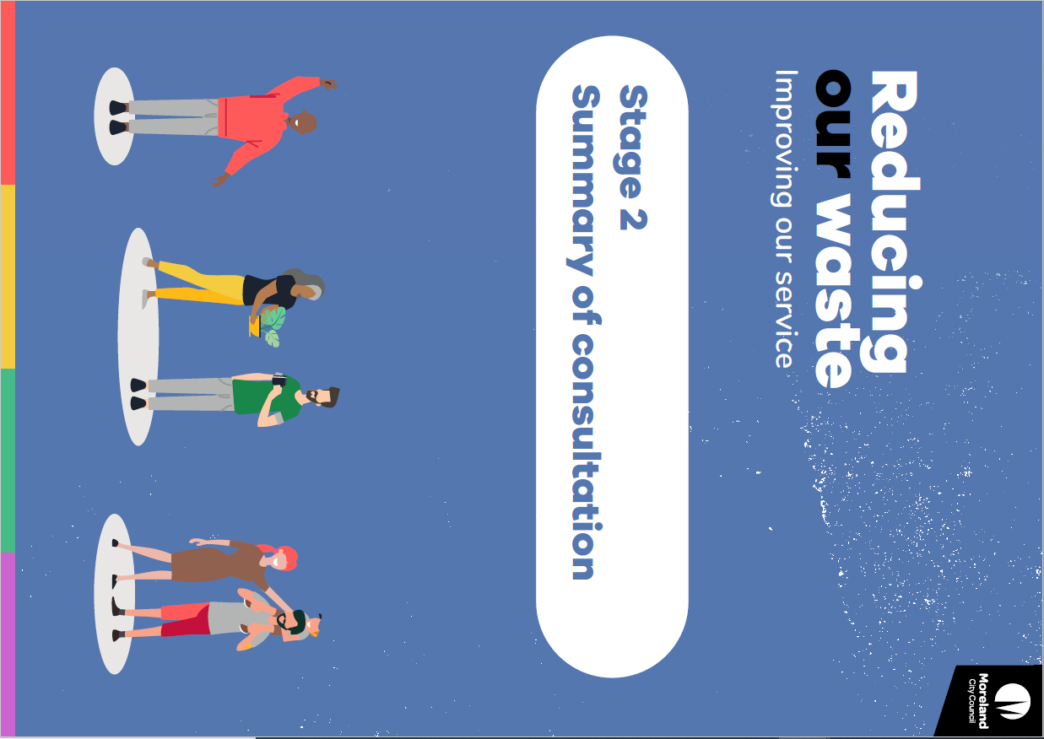

Reducing our waste. Improving our service.

Stage 2 Summary of consultation
The second stage of community consultation for this project started on 4 February 2021 and closed on 14 March.
Thank you to everyone who participated. Your feedback will help us draft a new Kerbside Waste Services and Charges Policy which will set out how often we pick up your bins and how we charge for the service.
You will have a chance to see our draft Policy and tell us what you think.
We had an enthusiastic response to the second stage of consultation.
This summary outlines some of the key themes we heard from your feedback and how this will help inform future stages of the project.

What did we ask?
We asked for feedback on a number of options for how our waste service could change as we move towards a 4-bin service. The options presented possible changes to standard bin sizes, collection frequency and other ways these services could be supported. This included:
- Three options for changes to Food and Garden Organics (FOGO) and Garbage
- Two options for changes to Recycling and the new Glass Recycling service, including possible alternatives for households that do not have room for a new glass bin
- Two options for the Hard Waste service.
We also asked for feedback about the types of households and community organisations that may be eligible for concessions to their waste charge and what this might look like.
To help guide these conversations, we prepared the Conversation Starter Kit which presented the pros and cons of each option and provided comparisons of the options.
You can find the Conversation Starter Kit on the Conversations Moreland website (https://conversations.moreland.vic.gov.au/waste) as:
- in an accessible version here: https://conversations.moreland.vic.gov.au/waste/conversation-starter-kit
- a PDF document here: https://conversations.moreland.vic.gov.au/download_file/view/1300/587

Who did we hear from?
The Moreland community is passionate about waste!
We received over 1,000 surveys from people all across Moreland, held six workshops, met some of our new Moreland Waste Champions and received emails and phone calls with your feedback.
Due to the pandemic, our consultation was conducted via the Conversations Moreland website, online workshops and by email and telephone.
In total:
- 1,049 people completed the Conversations Moreland Survey: Have your say on waste in Moreland
- 30 people attended 6 x 2-hour community workshops
- 49 people registered as Waste Champions
- 434 Quick polls were completed via Conversations Moreland website
- 27 surveys completed by schools, early years centres, community groups and not-for-profit organisations
- 45 Emails, phone calls and customer service requests received

Survey responses came from people who live all over Moreland, including people living in apartments and houses, people who live alone, in share houses or in families with children, and new residents and people who have lived in Moreland for many years.
We wanted to hear from different types of people living in Moreland to understand the waste needs of your households and homes.
We held workshops to hear from particular groups, but also had a strong response from a broad range of people in the online survey.
Of the 1,049 survey respondents:
- 21% of respondents lived in Brunswick
- 21% of respondents lived in Coburg
- 13% of respondents lived in Pascoe Vale
- 11% of respondents lived in Glenroy
- 10% of respondents lived in Brunswick East
- 8% of respondents lived in Brunswick West
- 8% of respondents lived in Coburg North
- 5% of respondents lived in Fawkner
- 5% of respondents lived in Pascoe Vale South
- 4% of respondents lived in Hadfield
- 3% of respondents lived in Oak Park
- 2% of respondents lived in Gowanbrae

Furthermore:
- 35% lived in terrace houses, villas, flats or apartments
- 4% were aged over 70 years
- 6% lived in a household with somebody with disability or who required medical assistance
- 20% lived in households with children aged under 4 years
- 27% lived in households with school-aged children
- 15% rent their homes.

What did we hear?
The Moreland community is passionate about waste and eager to know more about how they can make a greater contribution to improving waste services.
Overall, we found that the Moreland community is diverse and has many different needs and preferences for waste. There is no simple solution that will suit every household.
Keeping costs to households low and promoting better environmental outcomes, such as reduced waste to landfill and increasing recycling, were identified as important decision-making factors across all waste services.
People understand the need for change to support better environmental outcomes. However, change can be challenging, and people are keen for more information and education about why this change is needed and how it will affect them.

Which options were preferred?
Overall, we saw preferences emerging amongst the options we presented. People’s preferences were consistent across survey and workshop participants.

Food and Garden Organics (FOGO) and Garbage preferences:
57% of survey respondents preferred Option 1 - Weekly Food and Garden Organics (FOGO) and Fortnightly Garbage
32% preferred Fortnightly FOGO and Weekly Garbage
Only 11% preferred Weekly FOGO and Weekly Garbage

Recycling and Glass preferences:

66% of survey respondents preferred Option 1 – Fortnightly Recycling and Monthly Glass
34% preferred Weekly Recycling and Monthly Glass

Hard Waste preferences:
65% of survey respondents preferred Option 2 – Booked Hard Waste
35% preferred Municipal-wide collections

You can see an example of what these preferences would mean for your bin sizes and collection on the Conversations Moreland website here: https://conversations.moreland.vic.gov.au/waste/compare-your-4-bin-options.
However, we also heard that the options most preferred by participants do not suit everyone. You can read more about what we heard below.
These preferences and your feedback will be considered along with other technical information to help Council come up with a proposed service which will be presented in the draft Kerbside Waste Services and Charges Policy.

Food and Garden Organics (FOGO) and Garbage
Overall, we heard that collection frequency is the most important concern for garbage and FOGO bins.
People told us that FOGO bins and garbage bins can smell and attract pests if they are not collected often. This is particularly a concern in warmer months when food waste spoils more quickly, and for families with young children who are disposing of nappies.
Of the options presented, Option 1 - Weekly FOGO and Fortnightly Garbage was the most preferred overall. This option would mean that FOGO bins would be collected more frequently to reduce issues of odour and pests and it also presents the best environmental outcomes.
Participants were generally supportive of the FOGO service being rolled out across all households and would be supportive of opportunities to reduce the amount of waste going to landfill. We heard that households with FOGO bins found that their garbage bins did not fill up as quickly when their food waste was diverted to the FOGO bin.
Garbage and FOGO bins were identified as the heaviest bins when full. This was a concern for older people and people with disability or additional mobility requirements, particularly when considering larger garbage bin sizes. However, we also heard that street congestion on collection nights is an issue for people with reduced mobility and less frequent collection would help to reduce congestion overall.

Recycling and Glass
Overall, we heard that Option 1 - Fortnightly Recycling and Monthly Glass was most preferred.
While we often heard a preference to keep weekly recycling collections, many people also believed that a bigger bin collected less often would mean that the change would have a small impact.
The most common feedback we heard was concerns about a lack of space on people’s properties to store larger recycling bins and additional glass bins.
Some people also told us that a bin with a larger capacity could fit bigger boxes, so a fortnightly collection of a 240-litre bin would fit more recycling overall.
People living in townhouses, units, flats and apartments often told us that they do not have space to store individual bins and that residents of their development have shared recycling bins. Some people told us that shared bins contributed to contamination of recycling streams when people did not know how to recycle or as a result of dumped overflow rubbish when garbage bins were full.
The introduction of new glass bins was a contentious issue. We often heard that glass recycling only makes up a small proportion of household waste and that it would not be enough to fill the new bins. However other people were concerned that a 120-litre bin collected monthly would not be enough.
People living in in townhouses, units, flats and apartments who do not have room for a new bin preferred larger communal glass bins or glass recycling collection points as an alternative solution. Container deposit schemes were also raised often as an alternative to household recycling bins.
Convenience and ease of transport were the most important factors when selecting places for glass recycling drop-off points. Supermarkets and service stations were identified as suitable locations with car parking and can be accessed by public transport, walking and cycling. Some people suggested that glass bins on the street or in parks would be convenient, but that they would need to be managed to avoid safety risks such as broken glass.

Hard Waste
We asked people to consider whether they would prefer to keep the existing Hard Waste service or move to a model that provides two booked collections per household each year.
While many people liked the existing service, we heard that people liked that a booked collection could cost less, be more flexible, and could potentially reduce the amount of waste going to landfill. In particular, people suggested that being able to book a collection on demand would mean less rubbish dumped on streets.
We often heard about opportunities to ‘scavenge’ or salvage hard waste under the current service. Some people saw scavenging as a way to upcycle and collect useful items, while others felt that it created mess and could be unsafe.
People who live in units, flats and apartments told us that space constraints in their homes and in common areas mean that they do not have room to store hard waste and that being able to book a collection as needed would be more convenient for them. This option was also preferred by rental households who liked the flexibility to access the service when starting or ending a lease.
Some people living in apartments serviced by private waste contractors suggested that Hard Waste could be extended to all properties.

Waste charge
We asked people to provide some feedback about how the waste charge should be applied and what kind of users or households should be eligible for a concession.
Overall, we heard that the waste charge is a complex issue and that public awareness of the charge and how it works is fairly low. This made discussions about the waste charge challenging for many participants.
The waste charge is a fee attached to Council rates notices and is paid by property owners in Moreland. It must cover the entire cost of Council waste services.
Costs to households was frequently raised as a concern when discussing service options. This showed us that affordably is important.
We also heard that the waste charge could be used as an incentive to encourage people to reduce waste and improve recycling practices by charging reduced charge to households that generate less waste.

Next steps
The next phase of consultation will begin later in 2021. At that stage we will present the proposed changes to our waste services and ask for your feedback on the draft Kerbside Waste Services and Charges Policy.
We will update the website as we get closer to the next stage of consultation to let you know how you can get involved. Visit the website here: https://conversations.moreland.vic.gov.au/waste
Register for updates on the project website so you can stay up to date with project announcements.

