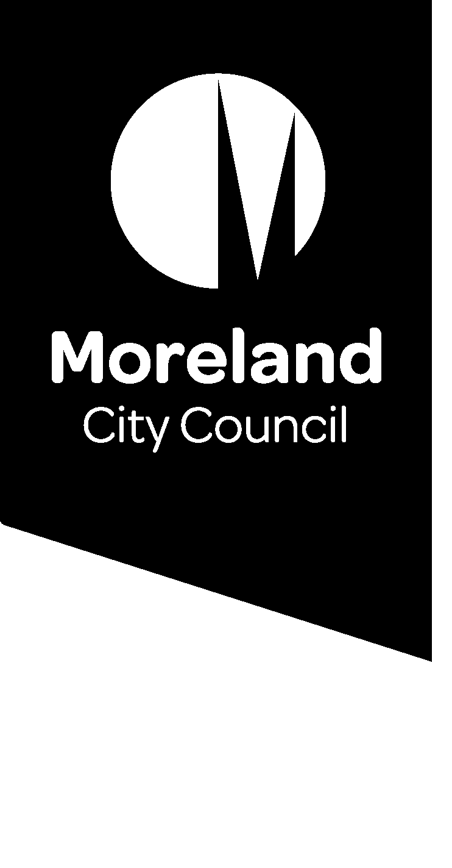

Reducing our waste. Improving our service.
We’re investigating how we can reduce waste, improve our waste service and move to a new four-stream service that separates garbage, comingled recycling, food and garden organics and glass.
We’re consulting the community to help us develop a system that is right for Moreland. This summary outlines some of the key themes we heard from your feedback so far.

Summary of early consultation
The first round of community consultation started on the 20 July 2020 and included:
- Surveys and virtual sticky notes via our online engagement platform, Conversations Moreland
- Feedback via telephone drop in session and project email address
Due to the COVID-19 pandemic, we were not able to talk to people face-to-face.
The first round of consultation closed on the 21 August 2020.
Thank you to everyone who participated. Your feedback will help us design the next round of consultation planned for later in the year.

Who did we hear from?
We had a strong response which included:
- 436 web survey responses
- 149 virtual sticky notes on the project website
- 140 responses to the website quick poll
- 15 conversations during the phone-in session
- 12 emails to the project email address
- 223 comments on our Facebook posts
We heard from people all over Moreland, including:
- people living in apartments and houses
- people who live alone, in share houses or in families with children
- new residents and people who have lived in Moreland for many years
- people who speak languages other than English

What’s working well?
Overall, we heard that there are many things that you like about our waste services. The top three things that you told us are working well are:
- The food and garden organic (FOGO) service.
We heard that since FOGO bins were introduced, household garbage has reduced and that you appreciate Council’s support to better environmental outcomes.
- The current bin collection frequency.
The weekly collection of garbage and recycling is appropriate for the amount of waste households are currently generating.
- The service is reliable and easy to use.
It helps households to recycle effectively and reduce the amount of waste going to landfill.
We also heard that the current service is flexible enough to respond to the needs of different households, including offering a range of bin sizes and fast and easy replacement for lost or damaged bins.

What could be improved?
We asked you what could be improved about the existing service. Some of these are issues that can be addressed through this project and others help us understand where we can provide more information or support to assist households. You had many suggestions, including:
- Providing more opportunities to learn more about recycling and waste. Have more information available to help households reduce their waste and avoid contamination in the recycling streams.
- More opportunities for soft plastics recycling through council services or council facilities.
- More frequent collection of the food and garden organic (FOGO) bin as households found that this filled up more quickly than the garbage bin and because you were concerned about odour.
We also heard that bins take up a lot of space on your properties and that you are concerned about kerbside congestion on bin night. Some people also suggested that there are opportunities to improve the standard of collection to avoid litter drop from garbage and recycling trucks.

What are your big ideas?
In your feedback, we heard some big ideas about what you would like to see in the future. Some of these ideas will help us improve our service, while other suggestions we won’t be able to address directly as they are outside of Council’s control.
Your ideas included:
- Shared bins between neighbours or communal drop-off points to reduce the number of bins that need to be stored on private property and to allow people to dispose of waste and recycling at a frequency that suits them.
- Introducing different rates and fees to encourage households to reduce waste and improve recycling.
- Ensuring commercial waste providers servicing apartments also provide a consistent service, including food and garden organics (FOGO) and recycling.

Next steps
The next round of consultation will explore some of these themes and opportunities in more detail.
All consultation is now on hold while we prepare for Council elections in October, however you can find out more about the project and our waste services by going to conversations.moreland.vic.gov.au/waste.
We will provide further information and updates after the election.

