Help us create a new

Food System Strategy

We want to hear from you!

How to provide your feedback

Scan the QR code
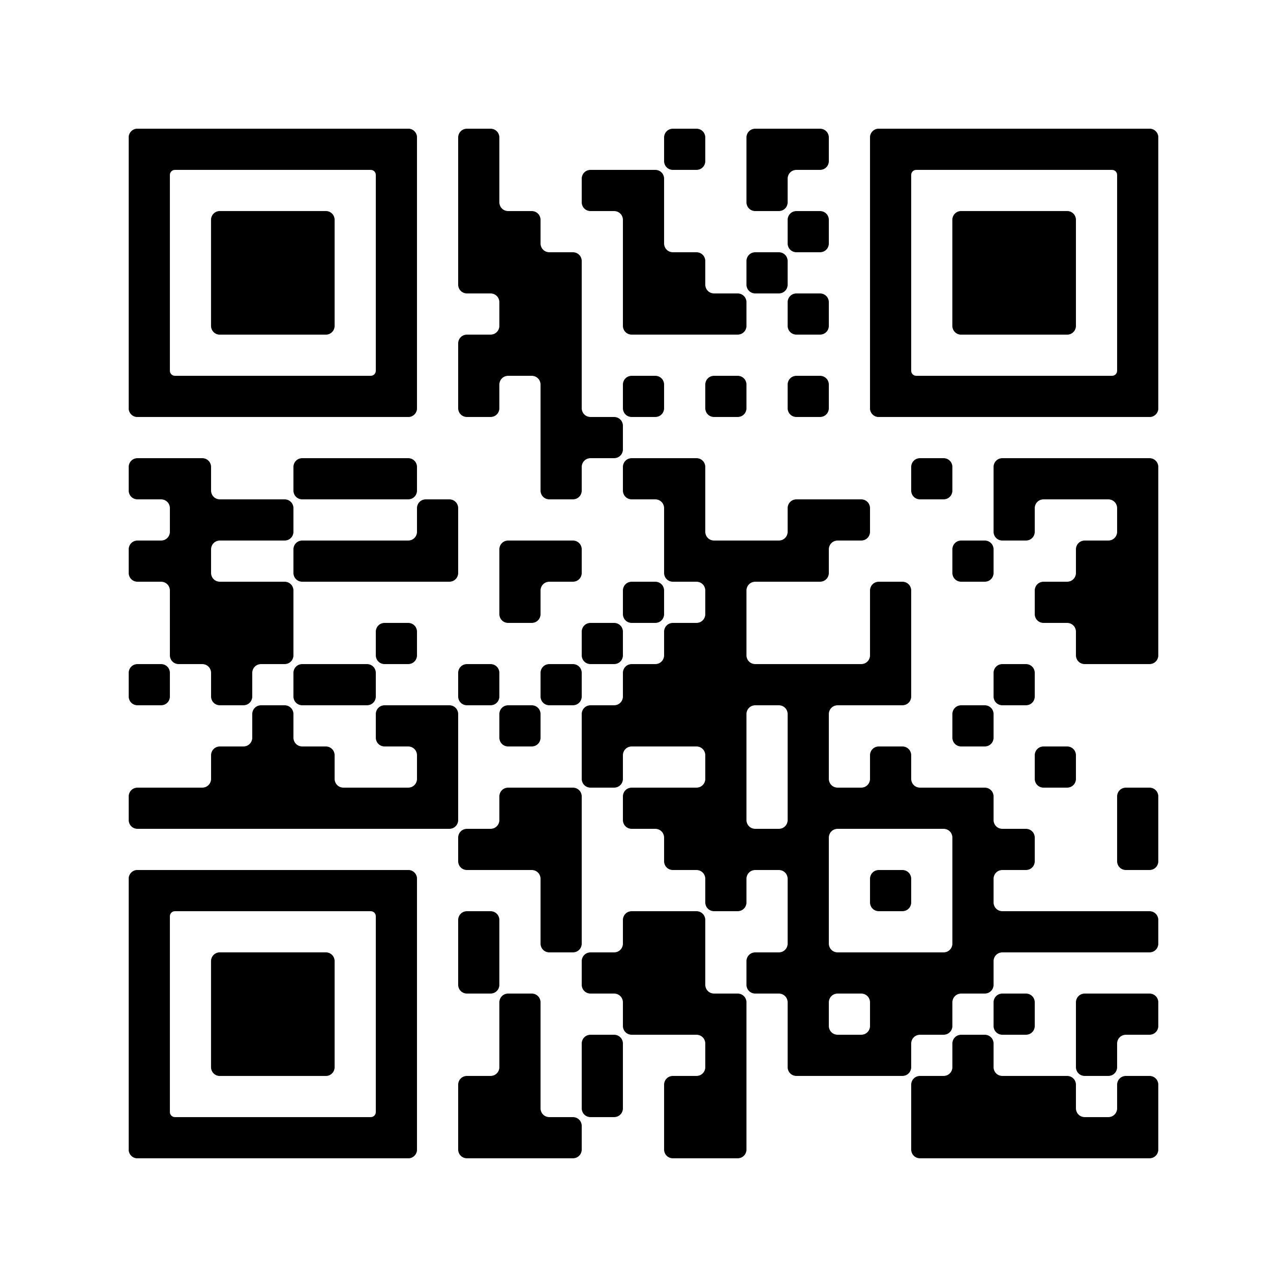

Call Us
9240 1111

For more information
conversations.merri-bek.vic.gov.au/food-system-strategy

We are creating a new Food System Plan and we need your help.
The term ‘food system’ means all the steps involved in growing food to when it arrives on your plate.
This includes how food is grown, harvested, packaged, processed, transported, marketed and consumed.
We want to know where you currently source your food, what challenges you face in accessing food and what you think would improve the food system in Merri-bek.
We need your ideas so that we can make sure the food system in Merri-bek is sustainable.
Survey closes on Friday 19 April.

