Community Budget Ideas
  - Terms and Conditions
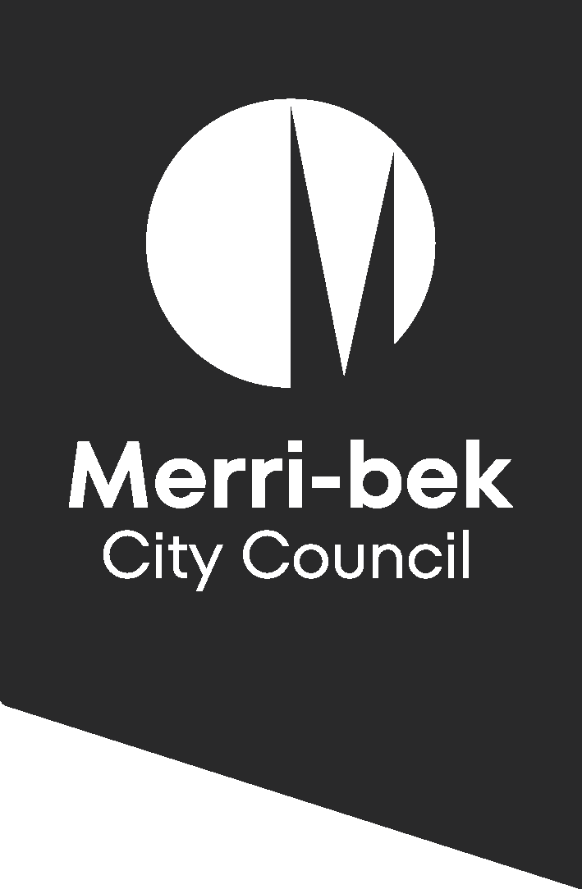

Terms and Conditions
All ideas must be in accordance with the following terms and conditions:
- The idea must demonstrate a strong community benefit.
- The idea must be for a once-off project or initiative that can be delivered by Council between 1 July 2024 and 30 June 2025.
- The idea must not cost more than $160,000 to implement.
- Merri-bek City Council has allocated $250,000 for Budget Initiative as part of the 2024/25 budget
- The idea must be lodged by 11.59pm, Sunday 21 January 2024. Applications received after this date and time will not be considered.
- One submission per individual, community group or sporting association is permitted.
- Where there are multiple submissions for the same idea, Council reserves the right to determine which submission will be put forward for consideration.
- If multiple/like submissions for the same idea are received and there is no formal community group/sporting association attached, we will group these submissions and review them as one package.
- As a condition of entry, you agree the name on the application can be made public and promoted on Council’s communication channels.

Tips for your application
Demonstrating strong community need
Each application must demonstrate how the idea meets a strong community need.
A simple way of thinking about this is:
- What is the problem or opportunity?
- How does it affect or impact the community?
- What difference would your idea make?

Council will consider how your idea aligns with strategies or priorities of Council Plan 2021 – 2025
General advice
- Ensure submission is specific enough that other community members relate to it, but not so specific that it will appeal to only a subset of the community
- Concise (less than 150 words is ideal) so that the voters don’t gloss over a big wall of text
- Feasible to achieve within one year
- Includes a call to arms/direct appeal to voters (voters are more likely to engage)
- Follow this structure; idea, explanation, benefit

Sample Submission
Title: Triple Council’s public artwork program
Describe your idea: I propose tripling Council’s public artwork program to spend on murals, sculptures, pop-up installations and other forms of public artwork across the entire municipality.
Public artwork is culturally important, adds enormous value to the aesthetic and economic vitality of our diverse communities, and is a cost-effective way of reducing graffiti. Furthermore, public artwork instils a sense of pride in community members, increases local awareness and is a fantastic contribution to the amenity of the city.
Merri-bek is home to a vibrant arts community; our city should reflect that and give more opportunities for local artists to exhibit their skill. If my fellow community members have seen the beautiful artwork at Garrong Park, they will know that this is a program worth investing in!
Cost of idea: $0-$50,000
Basis of costing: In Council’s latest adopted budget, $20,000 was allocated in 2024/25 to public artworks. Tripling this to $60,000 would cost Council an additional $40,000.
Suburbs: All

Privacy Collection Statement
Merri-bek City Council is committed to protecting your privacy in accordance with the Privacy and Data Protection Act 2014 (Vic) and the Health Records Act 2001 (Vic).
The personal information requested on this form is being collected by Merri-bek City Council for the Community Initiative project and may also be used to update your personal information otherwise held by Council (for example, contact details including email address, phone number). The personal information may be disclosed to Social Pinpoint for the purpose of reporting on the entries received and may also be used by Council for related purposes.
It will not be disclosed to any other external party without your consent, unless required or authorised by law. You can gain access to your personal information you have provided to Merri-bek City Council and if you wish to alter it, please contact Council’s Privacy Officer via telephone on 9240 1111 or e-mail at Privacyofficer@Merri-bek.vic.gov.au.

