Open Space Strategy
  - Discussion Paper
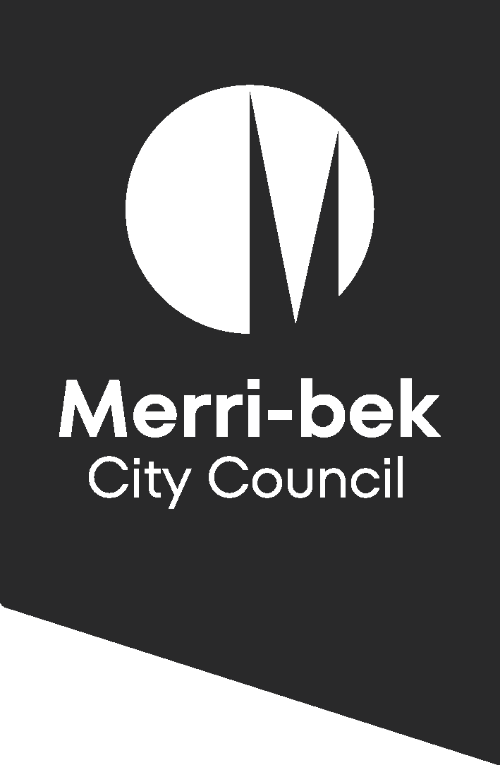
Acknowledgement of Country
Merri-bek City Council acknowledges the Wurundjeri Woi-wurrung people as the Traditional Custodians of the lands and waterways in the area now known as Merri-bek. We pay respect to their Elders past and present as well as to all First Nations communities who significantly contribute to the life of the area.

Table of Contents
1. Purpose of this Discussion paper 4
What is open space? 4
What is Council’s role and why are we doing this? 5
2. Timeline 6
3. A future Merri-bek 6
Population growth and densification 6
Objectives for Council – what is our vision? 6
4. Opportunities 9
Increased use of open space during the COVID-19 pandemic 9
A Park Close to Home 10
Acknowledging Traditional Owners 10
Gaps in our open space network and quality of our open space 11
Demand for open space and access to open space 11
Facilities for BMX and mountain bikes, cyclocross and skateboarding/scooters 14
Need for creative play / bush play 15
Promoting Arts and Culture in our open spaces 15
Improving and enhancing our local nature, biodiversity, and waterways, and responding to climate change. 17
Funding for open space 19
5. Council would like to hear from 21
Next steps 22
Key Reference Documents and Legislation 22
Key Reference Documents 22
Key Legislation 22
Merri-bek City Council documents 22

Purpose of this Discussion paper
Council’s current Open Space Strategy 2012 – 2022 is being reviewed, and we will create a new Merri-bek Open Space Strategy. This is important because as Merri-bek’s population continues to grow, we need to have a strategy that guides how Council manages open space. This will help make sure our residents and workers have access to quality public open space that meets their needs - for now and into the future.
This discussion paper is a summary of opportunities and challenges related to open space. It intends to help with the discussion we want to have with our community about our open space, and how we can better provide open space for our diverse and growing Merri-bek community.
We would like to acknowledge and thank the community for feedback about open space that we have already received in recent years. This has included feedback received during consultation for our Nature Plan in 2020; during the creation of our 2021-2031 Community Vision; when we have designed specific parks and open spaces with our local community, such as the recent upgrades to Kingsford Smith Ulm Reserve; and during recent and current engagement for projects in open space, such as the Brunswick Velodrome pump track.
We also thank the community for the emails, phone calls and email enquiries about open space. This has helped us improve the maintenance and condition of our open spaces as well as help us confirm some of the things that a new Open Space Strategy should address.
We also thank the community for many difficult conversations we have had, including when discussing safety and the continuation of devastating events, including events along our Creek corridors. We will continue to explore these with the community and build upon the Merri Merri Wayi work and ways that we can help make our open space safer.
When we create our new Open Space Strategy, we want to ensure that we hear from all parts of our community and how they use and value open space. This Discussion Paper intends to start this conversation to help create our new Strategy and together plan for our future open space needs.

What is open space?
Open space is the term used to described land used by the community for outdoor recreation and leisure, such as for: playing, relaxing, walking, jogging, dog walking, organised sport, informal sports recreation, and active commuting. It also includes land which has biodiversity and nature value, such as our Merri Creek and Moonee Ponds Corridors. Open Space also refers to land within private ownership, such as schools, golf courses and cemeteries, which the public may have restricted access to.
The City of Merri-bek has many unique and wonderful open spaces and nature experiences. Our Merri Creek and Moonee Ponds Creek corridors provide excellent walking and running paths, nature experiences and bush play, while our urban and suburban parks, playgrounds and sport fields provide opportunity for more formal play and sporting and recreational activities.
Council manages a diverse portfolio of over 350 open spaces, including:
- Sports facilities, grounds, and pavilions, including allocations to specific sports club for specific uses and sports
- Over 135 playgrounds of differing sizes and equipment types
- 54 sports grounds
- Various wetlands, raingardens and stormwater harvesting systems
- Skate parks, pump tracks and similar BMX facilities
- Exercise equipment in parks
- Park shelters, water fountains, rubbish bins, etc.
Council is also proactively creating new open space via the Park Close to Home program and is creating new urban parks, which is helping ensure our residents have access to open space within 300m (high density) or 500m of their home. This has successfully seen Council create new parks across the municipality in recent years, such as the Bulleke-bek Park in Brunswick and Citadel Park in Glenroy.

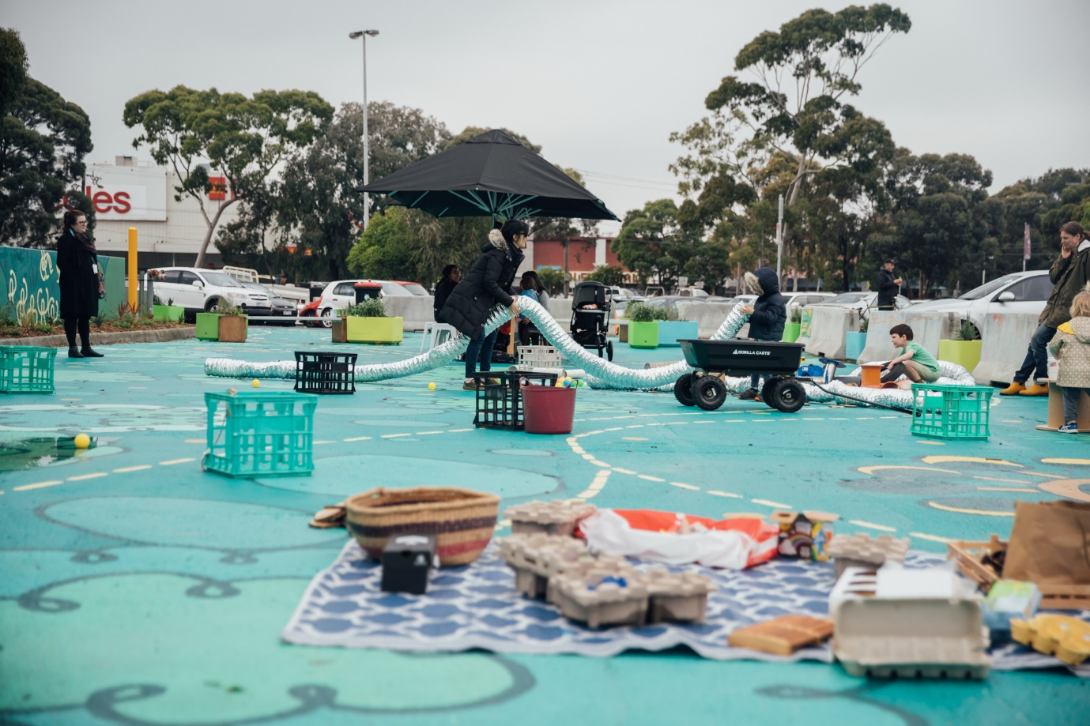
Figure 1: A pop-up playground in Coburg.

What is Council’s role and why are we doing this?
The current Merri-bek Open Space Strategy focussed on the time period of 2012 – 2022. There have been many changes in open space in recent years that we need to ensure we are managing. Impacts such as the COVID-19 pandemic, population increase, and housing densification have seen the usage and demand for our open space increase. Our open space is also seeing the impact of climate change – from our waterways experiencing greater flooding events, to our open spaces experiencing increasingly warm summers and heat waves.
Council needs to ensure we are adequately providing open space for our residents’ needs, as well as continue to enhance our biodiversity and nature in open space. The creation of a new Open Space Strategy will assist Council in providing open space for now and into the future. We will investigate population growth and housing densification and explore where access to open space needs to be improved.
We will explore where we need to create new open space, such as new playgrounds, new information sports spaces and new BMS / skate parks / pump tracks, or a combination of different uses. We will also explore how open spaces can support multiple values and multiple uses and howe we can accommodate these.
Many open spaces support multiple values and uses and need to be planned and managed as such.
The new Open Space Strategy will ultimately be incorporated as a reference document in the Merri-bek Planning Scheme. Tt will provide the key strategic direction for the planning, acquisition, management, and development of public open space. It will also inform a review of the Public Open Space contribution rate in the Merri-bek Planning Scheme.

2. Timeline
Council is aiming to prepare the Final Open Space Strategy for Council endorsement in December 2023. This will include the following:
- A new Merri-bek Open Space Strategy
- A background technical report exploring population growth, needs and open space gap areas
- A 15-year open space project list, which will inform the required investment and land acquisition needs to fulfil community and Council needs identified in the new Open Space Strategy.

3. A future Merri-bek

Population growth and densification
Through the period of the current Open Space Strategy 2012 – 2022 , Merri-bek’s population has greatly increased. Between the years of 2016 and 2021 specifically, our overall population increased by approximately 5.4%. Population forecasts estimate that our population will continue to increase which will have an influence on the quantity and type of housing that Merri-bek needs today and in the future. The share of people living alone in medium and high density housing is also growing which will lead to smaller homes (with smaller backyards).
The new Open Space Strategy will take future population growth and housing densification into account. Population and densification forecasting is being explored now as this Strategy is being created. The creation of the new Strategy will therefore explore our Merri-bek future and what new (and type of) open space is needed.

Objectives for Council – what is our vision?
The new Open Space Strategy will guide the future strategic direction for open space in Merri-bek. It will also align and enhance related open space objectives within the Victorian State Government ‘Open Space for Everyone’ metropolitan Melbourne-wide strategy, which has the following vision:
“Melbourne is a city in nature with a flourishing and valued network of public open space that is shared and accessible by everyone.”
The new Open Space Strategy will also build upon the Merri-bek Community Vision 2021 – 2031, which is a guiding platform for our municipality. The Community Vision is that:
“Merri-bek is our home. We respect and look after our land, air, waterways, and animals. We care for our people and celebrate our diverse stories, cultures, and identities.
“Merri-bek is enhanced by all of us supporting our local businesses, arts communities and social organisations.
“We work together proactively and transparently to continue to create a:
- vibrant
- safe
- healthy
- resilient
- innovative
- regenerative community.
“Many faces, one Merri-bek.”

The vision includes the following Themes:
Theme 1: An environmentally proactive Merri-bek:
“In 2031, Merri-bek is carbon neutral, embracing an entirely renewable energy system, innovative management of waste, and accessible active transport.
We have a circular economy, passive housing, food security, ample green spaces and canopy cover led by a well-informed proactive community.
We are a community connected to Country with healthy flora and fauna, through protection of ecosystems”.
Open space is precious, and our open space is integrally woven to the Wurundjeri Woi-Wurrung people, the Traditional Owners of the land and waterways in the area now known as Merri-bek. Open space has an important role in environmental stewardship and protection. This ranges from our nature and biodiversity within and along our creek corridors (Merri Creek, Moonee Ponds Creek, Merlynston Creek, Westbreen Creek and Edgars Creek), to ensuring we enhance our tree canopy and native grasslands. Our new Open Space Strategy will progress this Theme and its focus on environmental action and connection to Country.
Theme 2: Moving and living safely in Merri-bek:
“In 2031, Merri-bek is safe. Our streets are safe for pedestrians and cyclists, day and night. Everyone in Merri-bek is able to live in their homes without fear from others, both known and unknown.
In Merri-bek, we actively look out for each other and are well supported to do this by Council”.
Our open space plays an important role in promoting safety, including when using open space and moving in open space – such as promoting safe transport when integrating cycling corridors with open space. Council has also been working closely with stakeholders when trying to improve safety in our open space. The new Open Space Strategy will explore how we can further progress this work and this theme.
Theme 3: A healthy and caring Merri-bek:

“In 2031, the Merri-bek community has healthy bodies and minds.
We have our basic needs met. We have ready access to mental health, crisis and domestic violence services as well as high quality health care.
Moreland has reliable housing, nutritious food, with ample opportunities to move our bodies, keep our minds active and socially connect. Access to these are tailored to the unique needs to our diverse community. ”.
No one is lost between the cracks”.
We acknowledge the important role open space has in promoting a healthy and caring community. The new Open Space Strategy will explore this Theme, including ways we can promote greater use of open space and ways we can improve our open space to ensure it meets all of our community needs.
Theme 4: Spaces and places in Merri-bek:
“In 2031, living and working in Merri-bek is easy and enjoyable. Housing is affordable and caters for vulnerable and lower income groups. Our buildings are smart, green and fully integrated into the surrounding environment.
Merri-bek’s public and commercial spaces bring people together in diverse ways. Acknowledging the unique strengths in different areas of Moreland, the council and community support the development of vibrant hubs of arts, businesses and recreation”.
Open Space has an important role to play in making our spaces and places enjoyable and accessible. The creation of our new strategy will include an engagement phase which aims to hear from a wide range of our diverse community, to ensure we are including all of our community in the new strategy.

Theme 5: An empowered and collaborative Merri-bek:
“In 2031, Merri-bek is a place that engages meaningfully and has a real commitment to collaboration.
The community is aware of all council activities and trust in decisions and processes. The community will know where the unmet needs of our neighbours are and will be actively engaged in working towards a brighter future for all”.
Council wants to understand how the community sees the vision of open space in Merri-bek and how we can ensure that the vision appropriately represents all community members.
Council wants to know:

How do you use and value our open space?
What makes your proud / not proud of open space in Merri-bek?
What would make it easier for you to access open space?
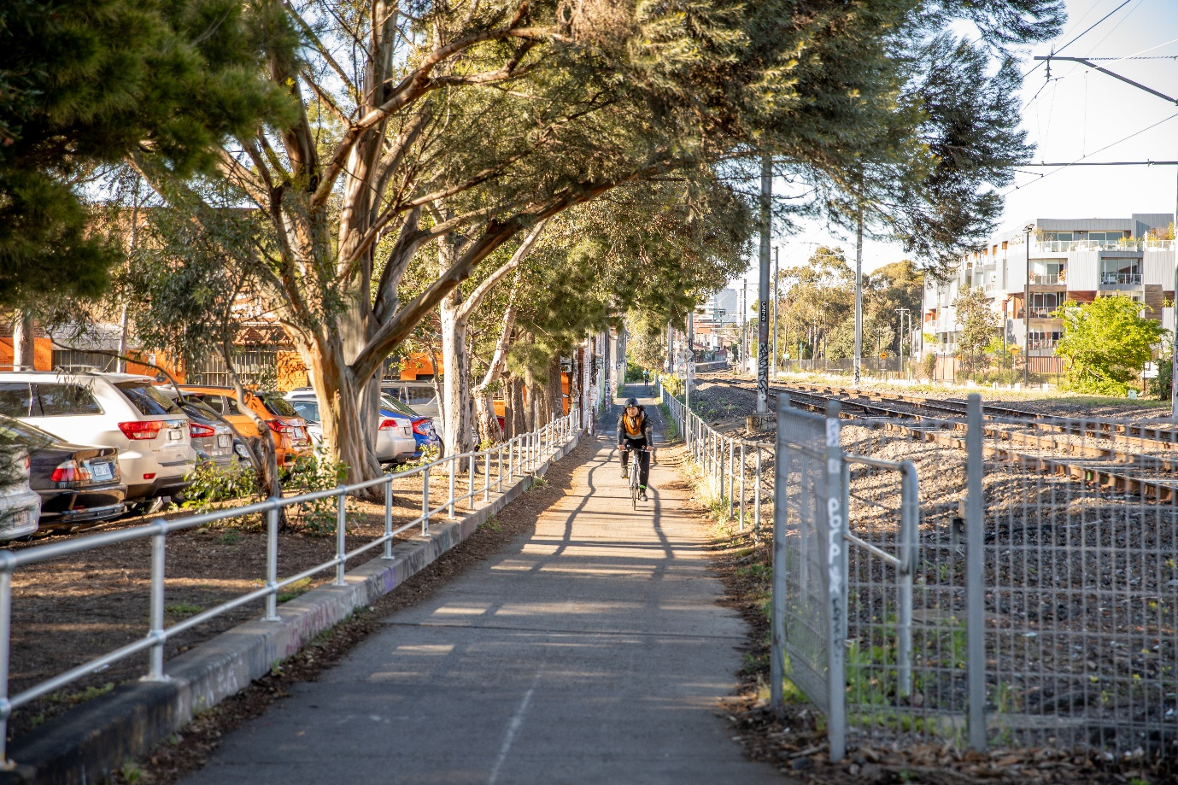
Figure 2: Cycling along the Upfield Corridor.

4. Opportunities
There are many opportunities for Merri-bek in managing and enhancing our open space, including:

Increased use of open space during the COVID-19 pandemic
The COVID 19 pandemic has changed the way people live, work, and get around. It has also changed how we value and rely on our open space. Anecdotal stories from residents have included residents using open space more and in different ways than before the pandemic. This includes discovering new local parklands and using creek corridors they had not previously used. This was particularly highlighted in Merri-bek during several periods of 5km radius lockdowns when our community members were confined to their 5km locale. It has ultimately increased focus and attention to the importance of local and varied open space.
Concurrently, the pandemic also increased pressure upon our open space due to unprecedented use.
Before the pandemic and during lockdowns, our Merri-bek residents communicated the need for better quality open space. This includes the need for better formal sports facilities, providing safer informal open spaces, creating more dog parks, and enhancing our playgrounds.
This new appreciation of our open space provides an ideal and unique opportunity to reflect on how we use our spaces and how we can better provide for our residents and users in the future.

A Park Close to Home
Merri-bek has proactively been creating new areas of open space via the Park Close to Home program since 2017. Through this program, we have built several new open spaces and several more are planned in the coming years. This has included the Bulleke-bek Park, Brunswick, a new 2,300sqm park in central Brunswick, and Citadel Park, Glenroy, which both provide much needed open space for residents of nearby houses and apartments.
Our community has been extremely positive about these new parks and the program. The new Open Space Strategy provides opportunity to harness this positive feedback for input into new open spaces.

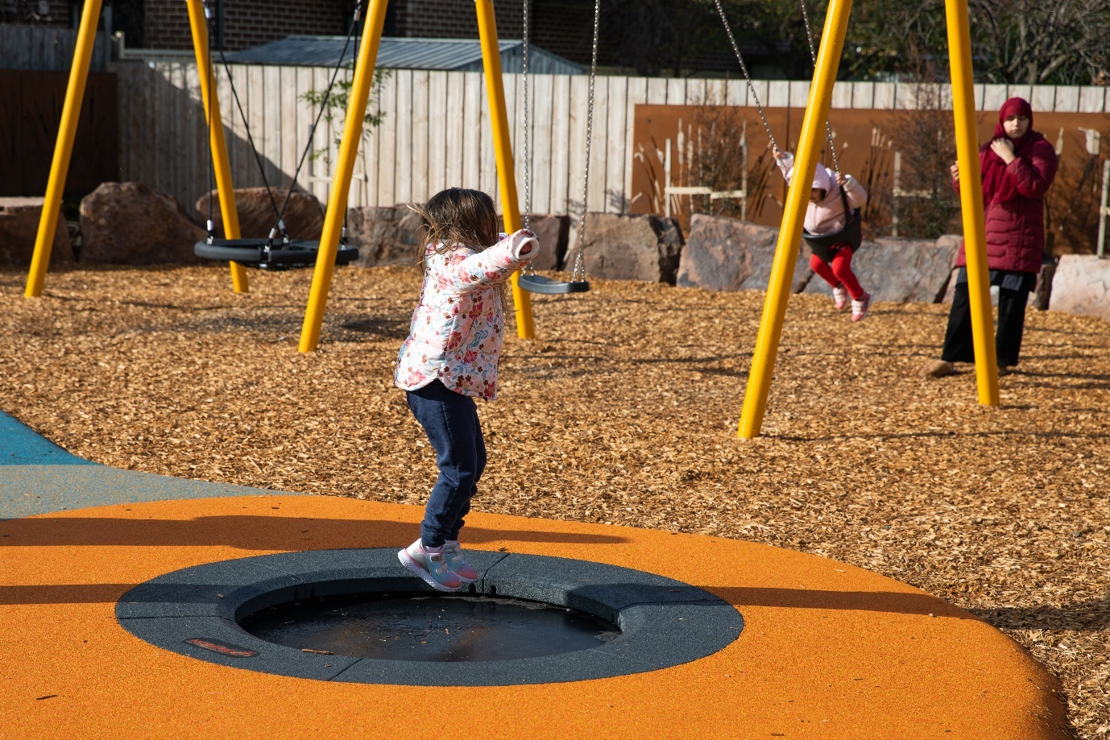
Figure 3: Citadel Park, Glenroy, created through the Park Close to home program.

Acknowledging Traditional Owners
Our open space exists on the lands of the Wurundjeri Woi-wurrung people, the Traditional Owners of the land and waterways in the area now known as Merri-bek. The creation of a new Open Space Strategy is a fantastic opportunity to demonstrate a greater level of respect for country and our open space. The new Open Space Strategy will explore how Council can increase integration of Traditional Owner philosophies and perspectives into how we use, manage, plan, and maintain our open space. We will build upon existing actions and discussions, such as the renaming of Council to Merri-bek City Council and the recent Merri Creek Parklands discussions. We will aim to work closely with the Wurundjeri Woi Wurrung Cultural Heritage Aboriginal Corporation throughout the creation of our new Open Space Strategy.

Gaps in our open space network and quality of our open space
Gaps in our open space network
The Park Close to Home framework aims to ensure all residents are within either 300m (if within high density zoning) or 500m of open space. To create open space in areas outside of these 300m and 500m distances, Council has been buying land on the mainstream property market and creating new parks. Council has created several news parks via this program, including:
- Bulleke-bek Park, Brunswick
- Garrong Park, Brunswick
- Citadel Park, Glenroy
Several parks are also in the planning and construction phase, including future parks at:
- 14 Frith Street, Brunswick
- 260 Sydney Road, Brunswick
- 498-508 Bell Street & 33 Westgate Street, Pascoe Vale South
- 41 – 43 Service Street, Coburg.
These new open spaces have been specifically developed to reduce the open space gaps identified in the Park Close to Home framework and improve community access to open space. There are however remaining gaps in our open space network which will require several new parks to be created.

Quality of our open space
Whilst we have also heard from our community that we need more open space overall, we have also heard about the need for specific types of open space and a need to improve the quality and maintenance of our existing open space. This includes specific requests for:
- Dog parks and dog park facilities (i.e., dog agility equipment, separate fenced areas, ‘small dog’ areas and ‘large dog’ areas)
- Creation or improvement of specific sport facilities (such as a hockey ground, more soccer pitches, and more football fields)
- Upgraded and additional playgrounds, and playgrounds with different focus
- BMX / mountain bike / cyclocross facilities
- Greater informal recreation spaces (such as running routes and linear corridors)
- Improved safety in our open spaces, including lighting, seating, improved view lines, etc
- Greater shade, drinking fountains, bins, seating, and BBQ facilities
- Overall improved maintenance across the entire open space portfolio in Merri-bek.

Demand for open space and access to open space
Our open spaces serve many functions, often at the same time. For example, a sports field can serve a function as a formal sports club ground, whilst also servicing a function as open space outside of playing hours for informal sport and recreation, and dog walking. Similarly, a playground can be a space for children to play as well as a congregation space for adults, as well as a space for nature and biodiversity habitat.
An emerging challenge is the increasing pressure and demand for our open space to serve many functions. This is further intensified by increased demand due to increasing population and urban densification. The strategy will explore this increasing pressure and demand and aim to provide a rationale for how Council will tackle these challenges.

Ensuring open space can be used by all
Council wants to increase open space usage and access to all persons within Merri-bek. We acknowledge however access to our open space, including specific facilities and locations, needs to be further explored and invested within. We have opportunity to ensure open space is more accessible for all when we create the new open space strategy, such as:
- Reviewing the condition of sports ground needed for formal sports, and other uses which may reduce the condition of these grounds.
- Exploring how we can increase access to our sports grounds, such as in the evening when a sports club has an allocation at a sports ground.
- Exploring how our playgrounds can cater to persons (children, parents, carers) who experience disability. This includes physical barriers that make open space difficult to access for persons with disabilities / mobility impairments including prams, such as: uneven terrain, stairs, lack of accessible parking, paths, and toilets.
- Explore how facilities in our open spaces can better cater for persons experiencing homelessness.
- Exploring how our open spaces can better include sensory considerations and provide for persons with sensory disabilities.
We want to hear from you:

What would make open space easier for you to access?
What facilities do you use in your open space?
What can Council do to make our parks more engaging for all genders?

Rising dog ownership
Merri-bek’s dog ownership has greatly increased in the last decade and is expected to continue to increase. Below is a graph showing registration of dogs in Merri-bek from 2017/2018 to 2022/2023 showing that dog ownership in the last 6 years has tripled. Furthermore, we know that dog ownership in high-density spaces is increasing, creating additional need for dog facilities within open space.

We have heard from some parts of our community that there are opportunities to improve facilities for dogs in our open space. The strategy will explore how we can better share open space for both dog walkers and other open spaces uses (such as formal sports).

Sharing our Open Space
Our open space areas often serve many functions and support a diversity of uses and users concurrently. Such an example is an open space sports field which has a formal allocation for use of a sports grounds in evenings and on the weekend for a formal sports group. This open space can also be an important open space for dog walkers, being a designated off-leash dog area, as well as providing space for informal recreation and informal sport.
Council officers, community members and sports groups have reported that at times, our open space has not been appropriately shared between users. Council will explore how we can enhance the sharing of our open space for diverse uses and users and how these spaces can co-exist harmoniously.
Council will also explore commercial leases in open space and opportunities to promote use of open space (such as cafes, yoga, personal training, etc).
We want to hear from you:

Do you want more dog parks / dog facilities – and what type? Fenced / non-fenced?
Do you want less dog off-leash areas and more on-leash areas?
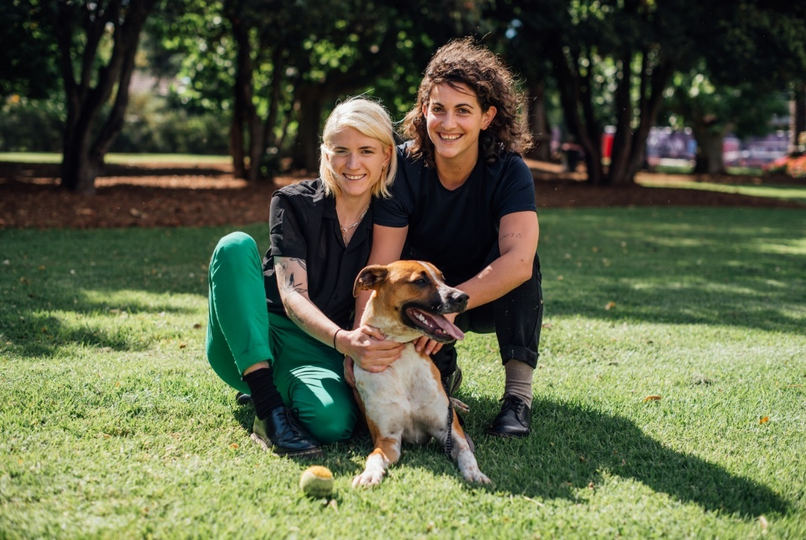
Figure 4: Open space for people and dogs.

Facilities for BMX and mountain bikes, cyclocross and skateboarding/scooters
BMX and mountain biking, cyclocross, skateboarding and scooters are increasingly popular activities in Merri-bek and surrounding Councils. Residents have contacted Council seeking the establishment of higher quality outdoor recreational facilities that include a BMX track / pump tracks/mountain bike paths/cyclocross/skateboarding/scooter facilities.
Council has heard this feedback from our community and is already building two facilities: one at the Brunswick Velodrome (in design phase for a pump track) and a second pump track at Richards Reserve next to the Coburg Velodrome, which has recently been completed.
We want to hear from you:

Do you think we need more BMX / mountain bikes facilities, and where?

The new Open Space Strategy will further explore the need for additional BMX / mountain bike / cyclocross/ skate/scooter facilities, including collaborating with adjoining Councils to create shared facilities. It will also balance the location of these facilities with other open space values such as biodiversity, including:

Need for creative play / bush play
Council recognises the need for children to have access to a variety of play and creative play spaces in the outdoor, natural world. The Merri-bek 2016-2020 Play Strategy identified that play using natural materials (stone, soil, leaves, plants), waterways, shade as well as formal playgrounds, is important to for children’s learning, health, and wellbeing. Whilst Merri-bek has an established network of playgrounds, it has been identified that creative play, such as play using natural materials (stone, soil, leaves, plants), may be lacking. The strategy will explore these facilities and our overall open space facilities for children, including our playgrounds.

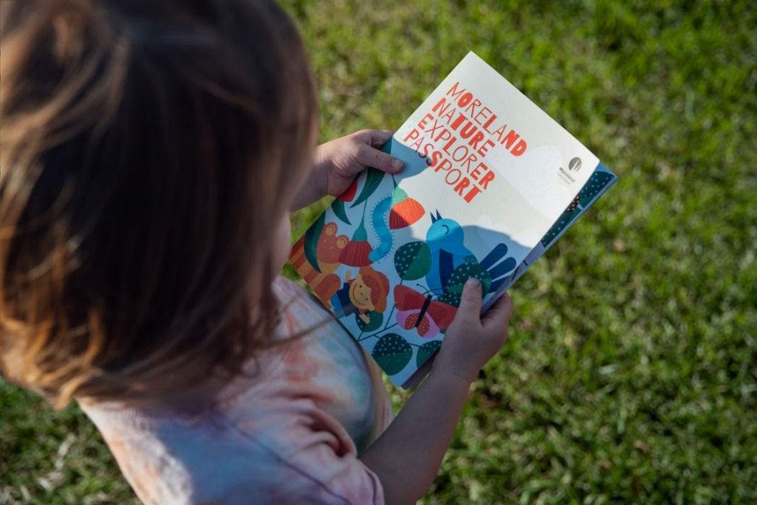
Figure 5: Merri-bek Nature Explorer Passport.

Promoting Arts and Culture in our open spaces
Our open spaces are a great opportunity to promote our unique and thriving Merri-bek arts and culture. The Strategy will explore how we can better promote arts and culture in our open space – such as via opportunities for events, artwork, or other activities (such as the Brunswick Music Festival held recently at Gilpin Park, Brunswick, or the Glenroy Music Festival at the Glenroy Community Hub). The strategy will also explore how we can celebrate and promote our Aboriginal and Torres Strait Islander and Wurundjeri- Woi-wurrung history, including in future events and open space improvements / additions.

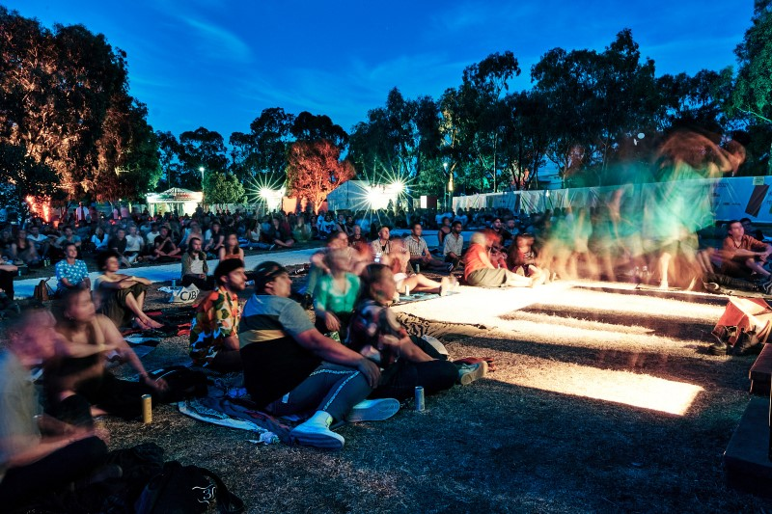
Figure 6: Brunswick Music Festival at Gilpin Park, 2022
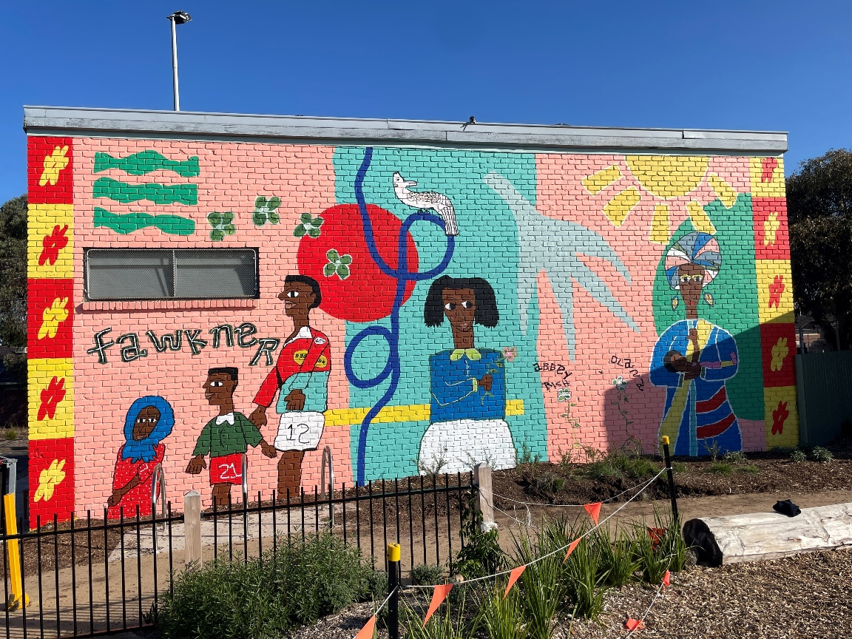
Figure 7: Mural at Charles Mutton Reserve.

Improving and enhancing our local nature, biodiversity, and waterways, and responding to climate change.
The Merri-bek Nature Plan, Merri-bek Urban Forest and Merri-bek Integrated Water Management (IWM) Strategies, together recognise the importance of protecting and enhancing nature, biodiversity, and our waterways in Merri-bek. These strategies greatly align with planning and enhancing our open space, as our waterways and key biodiversity and nature is largely within open spaces areas.
Council has undertaken key open space improvements along our waterways (in collaboration with agencies such as Melbourne Water, Moonee Valley City Council, Friends of Moonee Ponds Creek, Friends of Merri Creek, Friends of Edgards Creek and Merri Creek Management Committee). These projects have far-ranging benefits, such as improved creek health and biodiversity as well as improving the quality of our open space. An example is the Reimagining Moonee Ponds Creek Project, whereby concrete parts of Moonee Ponds Creek are being reimaged to create a more appealing Creek environment, improved waterway quality and much improved open space.
Council is also proactively increasing shade, tree coverage and biodiversity in the municipality via the Merri-bek Urban Forest Strategy and Nature Plan. The Urban Forest Strategy has a vision to transform Merri-bek into a municipality where healthy trees and vegetation are a core part of our urban environment. It aims to double tree canopy cover across Merri-bek. Concurrently, the Nature Plan provides strategic direction to enhance biodiversity and celebrate nature in our municipality. This includes projects such as community planting days, supporting Bush Kinder and early years nature engagement programs, and space for wildlife in the private and Council realm.
The Merri-bek Climate Risk Strategy describes how Council will proactively plan for and respond to the inevitable impacts of climate change. Our Merri-bek Climate Risk Vision is that, by 2030:

Council competently, accountably, and responsively manages climate risk, and
Merri-bek is climate-resilient, leafy, and liveable; with –
A climate-ready and resilient community with no one left behind.

We need to ensure our open space is resilient in the face of climate change and climate risk. This includes our parks being resilient during the la Niña wet weather patterns which typically have increased rainfall and flooding events, as well as being resilient during El Niño periods which typically have lower rainfall and potential drought. Furthermore, we recognise that our open space serves as a place of respite during events such as heat waves.
The new Open Space Strategy will explore how our open spaces align and promote this vision. This may include specific exploration of actions such as how can our open spaces are responding to climate change and specific climate risks, and how our open spaces continue to provide ecosystem services such as shade, water retention and cool transit corridors.

We want to hear from you:

How can we better promote nature play / bush play for our children and families?
How can we better promote arts and culture in our open space?
How can our open space be more resilience in the face of a changing climate?
The new open space strategy will continue to align our focus on nature and waterways with, and within, our open spaces. The strategy will also explore both Council owned and maintained land as well as privately owned and managed lands (such as the Northern Golf Course, Fawkner Memorial Park and schools) and their important role in promoting and enhancing local nature and biodiversity in our private open spaces.
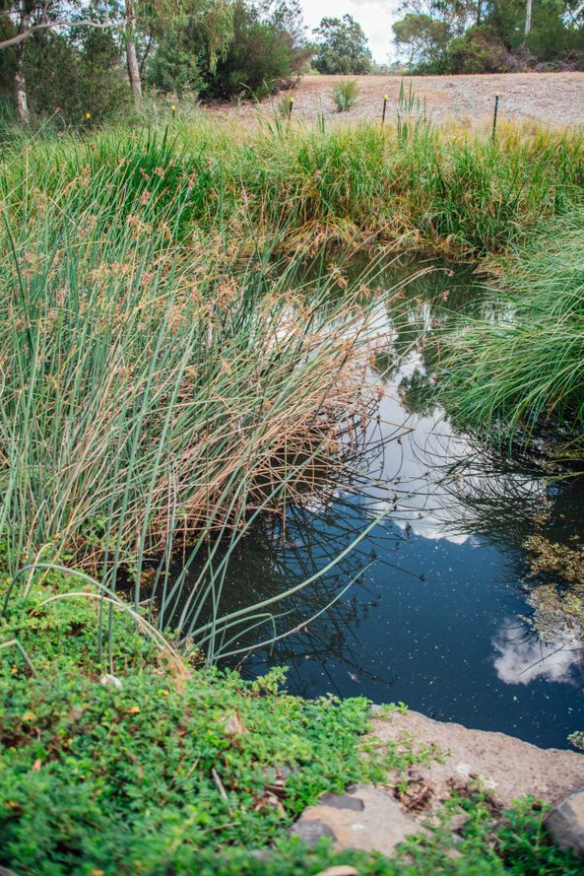
Figure 8: A wetland constructed to help improve Merri Creek.

Funding for open space

Rising costs
Funding for Merri-bek open space comes from various incomes streams: Council rates, external grants, and the Public Open Space Planning Scheme Contribution (Levy) (funds collected from subdivision of land). Council also collaborates with key partners, including Memorandums of Understanding and Committees of Management, which assist in establishing and maintaining open space.
A key, emerging challenge in providing open space for our growing municipality is the substantial rising cost of open space management and creation of new open space. To meet the open space demands created by an increasing population, Council purchases land on the mainstream property market to create new open spaces. An increasing issue is the increasing cost of land acquisition. In the years from 2018 to 2022, Council spent over $54,000,000 purely on land acquisition to create new parks. The design and construction of the park and playgrounds, seating and landscaping, was additional to this amount. Council has also purchased many other properties to create and enhance future linear open space corridors, retain parkland along our Creek corridors and improve biodiversity. From 2013 to 2019, multiple properties for these purposes have cost over $39,000,000.

Open Space Maintenance
Concurrently, the cost of upgrading and construction of open space is also rising, such as playground equipment and materials. In recent years, Council has experienced cost increases of 30% - 70% .
Furthermore, whilst Council is increasing our open spaces via the creation of new parks, our space portfolio maintenance portfolio is also increasing. Council has a portfolio of over 350 open spaces inclusive of 135 playgrounds, 54 sports grounds, various wetlands, creek corridors and stormwater harvesting systems, skate parks, pumps tracks and park shelters, which all require renewal and maintenance. We have many ageing playgrounds that require upgrading as they have not been upgraded for over 20 years. We are also seeing our open space and maintenance impacted by climate change – such as flooding in 2022 that made it difficult (and more costly) to maintain our open space.

Funding review
Council has a long-term asset planning approach that sets the strategic direction for asset construction, renewal and maintenance. This program can also be applied to our open spaces and future open space projects. The new Open Space Strategy will explore future open space projects, including projects in the short, medium and long-term timeframes. This is similar to other metropolitan Melbourne Councils, which are looking at open space in a 15 - 20 year project timeframe. This approach also has the potential to better inform the contribution land developers make toward the city’s open space needs.
The Open Space Strategy refresh will continue to explore issues around funding and seek to make recommendations to address key funding issues and shortfalls. One funding mechanism which will be investigated is a review of the Public Open Space contribution for land developers, which is part of the Merri-bek Planning Scheme.
The Public Open Space contribution is a statutory funding mechanism for land developers to make a financial contribution to the city’s open space provision when they subdivide land and put more houses on an existing lot. For example, a piece of land that formerly had one home is developed and subdivided to have two or more homes. This mechanism requires developers to make a financial contribution towards Merri-bek’s public open space improvements / acquisition of land, that are required to cater for the needs of the increased residential population resulting from the development and subdivision.
Council currently has some specified contribution rates in the Merri-bek Planning Scheme. By following guidance in a Victorian Government Practice Note and adhering to recommendations made by Planning Panels for other councils who are refreshing their Open Space Strategies¸ there is an opportunity for Council to review open space contribution rates in the Merri-bek Planning Scheme. This opportunity would ensure land developers make an appropriate contribution to the demand for the city’s open spaces.

We want to hear from you:

Should we explore ways for the Merri-bek Planning Scheme to include refreshed contribution rates, for land developers to financially contribute to the city’s changing open space needs?

What ideas do you have so we can better fund and allocate resources for our open spaces?

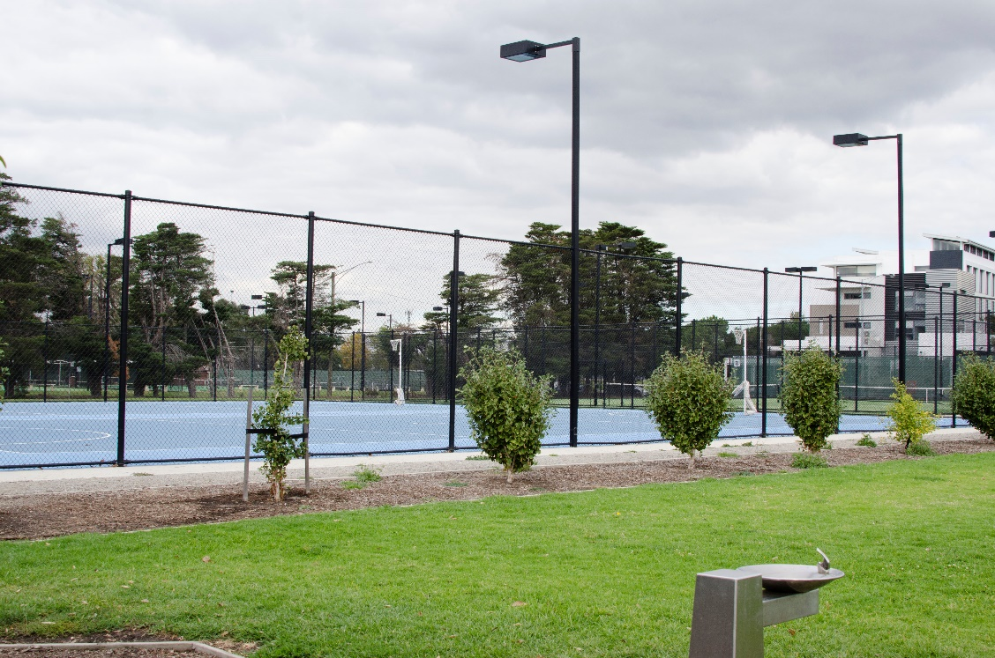
Figure 9: Netball facilities at Raeburn Reserve.

5. Council would like to hear from

Council would like to hear how you use and value our open space; what facilities you use; what you do not use and why; and any other feedback about our open space. We want to sure we are meeting the current and future open space needs of our community.
Council wants to ensure that we can factor in how our open space is used and valued for future decision making. Specifically, we want to hear from people to help Council:
- Prioritise the open space projects in the next 10 years and beyond in the best locations
- Create an indicative future project list for open space projects
- Understand how our space is used and valued
- Ensure all voices in our community are heard.

Council is seeking input from our diverse community about how our open space is used and valued,
and what aspects are working and what are not.

This will help us create new open space,
identify where to acquire new land for future open space,
and confirm what actions need to occur across Council to further enhance our open space for now and for the future.

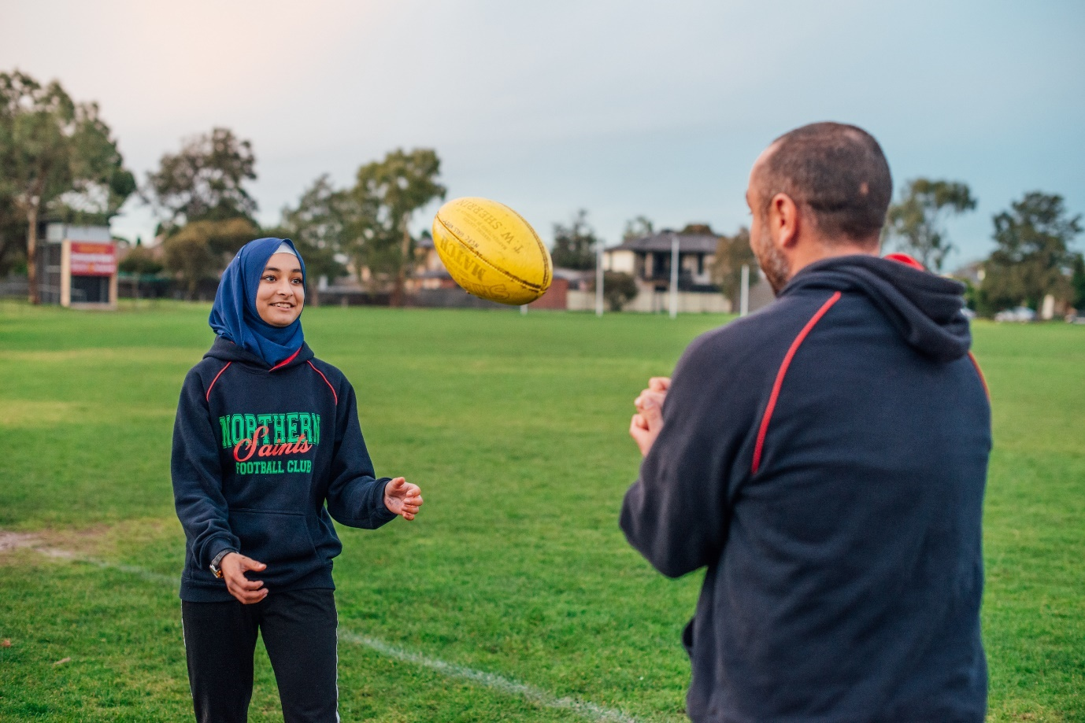
Figure 10: Football in open space.

Next steps
Council will be having key engagement activities, including events in our Merri-bek parks, an open space survey and workshops. Please stay updated by looking at conversations.merri-bek.vic.gov.au/open-space-strategy .

Key Reference Documents and Legislation
Below are the key documents that have, and will be, used to consider the context of the new Merri-bek Open Space Strategy.

Key Reference Documents
Victoria State Government
- Open Space for Everyone
- Plan Melbourne

Key Legislation
- Merri-bek City Council General Local Laws 2018
- Merri-bek Planning Scheme
- Planning and Environment Act 1987 and Subdivision Act 1988
- The Local Government Act

Merri-bek City Council documents
- Allocation and use of sporting facilities, grounds, and pavilions
- Climate risk strategy
- Community infrastructure plan 2022 – 2032.
- Disability Action Plan
- Draft Arts and Culture Strategy
- Edgar’s creek conservation and development plan
- Housing Capacity Study
- Integrated Transport Strategy
- Integrated water management strategy 2040 – towards a water sensitive city
- Merlynston linear park plan
- Moonee ponds creek chain of ponds
- Merri creek environs strategy
- Merri-bek children, young people and families plan 2021 – 2025
- Nature Plan
- Park close to home framework
- Play Strategy 2016 – 2022
- Sport and active recreation strategy 2020
- Urban Forest Strategy 2017-2027
- Urban heat island effect action plan & cooling the upfield corridor action plan
- Westbreen creek conservation and development plan
- Zero carbon 2040 framework

In 2016, the Merri-bek population was 162,561 persons and in 2021 was 171,351 persons: https://atlas.id.com.au/merri-bek .
Victoria State Government: Open Space Strategy for Metropolitan Melbourne 2021 – ‘Open Space for everyone’.
https://conversations.merri-bek.vic.gov.au/what-your-vision-fawkner-merri-parklands
Data is from Active Registrations with Merri-bek City Council.
https://www.merri-bek.vic.gov.au/globalassets/key-docs/policy-strategy-plan/merri-bek-play-strategy-2016-2020-_web.pdf
This was to create the parks at: West & Breese Streets, Brunswick; 55-61 Tinning Street, Brunswick; 260 Sydney Road, Brunswick; 14 Frith Street, Brunswick; 132-134 Cardinal Road, Glenroy; 41 – 43 Service Street, Coburg; and 498-508 Bell & 33 Westgate Street, Pascoe Vale South.
Costs obtained when comparing pre-covid costs and post covid costs. For example, a typical park seat increased from $860 to 1,280; installation of a typical drinking fountain increased from $7,8000 to $10,500.

