  - Fawkner Leisure Centre Redevelopment
  - Newsletter #3
Timeline
- March/April: Finalise membership details

- Friday 31 March: Outdoor pools close

- Saturday 1 April: Family Fun Day
- Popcorn machine and games

- Thursday 6 April: Final day of operations at Fawkner
- 10.30am – Members’ morning tea
- 4 – 6pm - Family fun night

- Friday 7 April: Centre closed for redevelopment

- Summer 2024/25:
Centre reopens.
Stage 1 works complete.

Refurbishment works commencing soon!

Fawkner Leisure Centre will be closed from Friday 7 April.
The Centre will reopen for the 2024/25 summer season.
Refurbishments will include:
- New outdoor 50m pool, children’s pool, and outdoor social spaces.
- New spa, sauna and a steam room
- Extension of the gym, new program space, cycle studio
- Improved access to the reception, foyer, and café lounge area.
Alternative membership options:
Active Merri-bek have presented existing members with several options to stay fit and healthy at other Merri-bek facilities:
- Brunswick Baths
- Coburg Leisure Centre
- Oak Park Sports and Aquatic Centre.
Members can also suspend their membership for the duration of the redevelopment. Please see reception staff to discuss your options by 6 April.
Visit the website or contact us for more information.
Web: active.merri-bek.vic.gov.au
Email: fawknerleisure@activemoreland.com.au
Tel: 03 9358 6600

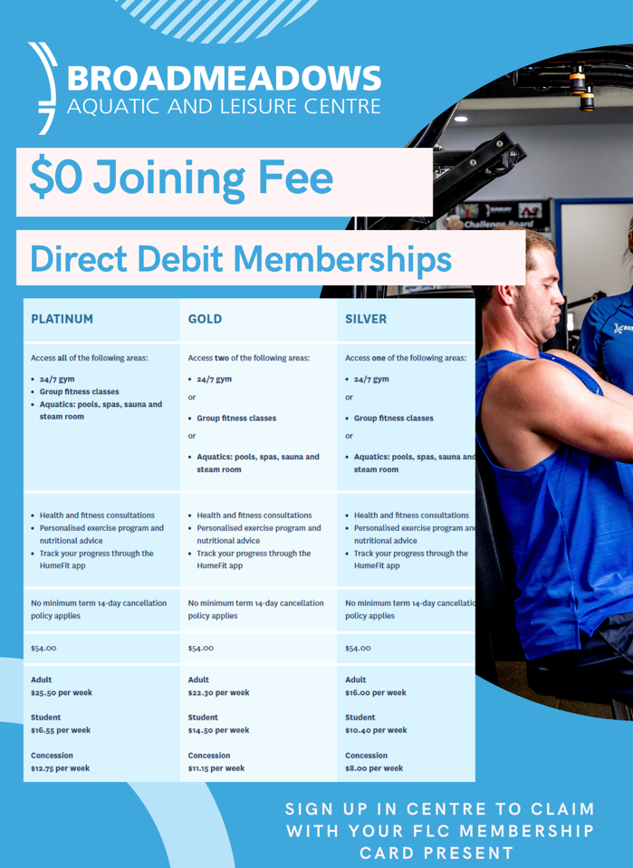
Broadmeadows Aquatic and Leisure Centre offer – no joining fee in April
During April, Hume City Council will waive the joining fee for existing Fawkner members who sign up at the Broadmeadows Aquatic and Leisure Centre. The facility is approximately a 15-minute drive away.
Contact Broadmeadows for more information.
Email: balc@hume.vic.gov.au
Tel: 03 9205 2670

