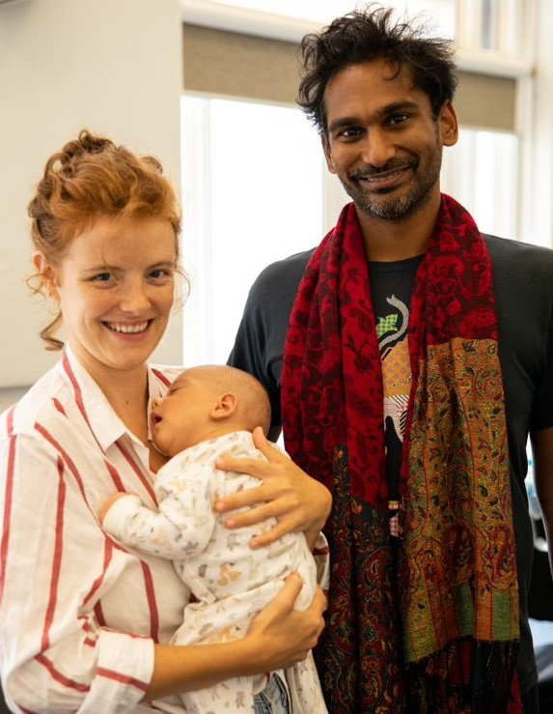

Children, Young People and Families Plan 2021-2025

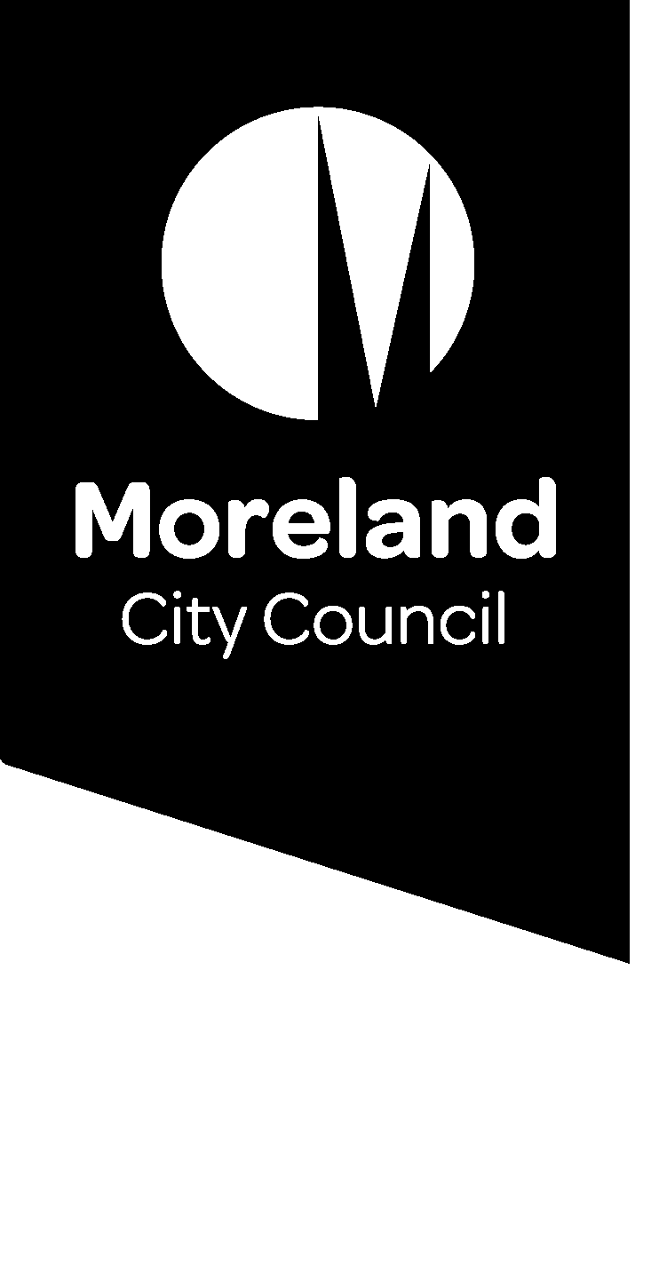

Acknowledgement of Country
Moreland City Council acknowledges the Wurundjeri Woi Wurrung people as the Traditional Custodians of the lands and waterways in the area now known as Moreland. We pay respect to their Elders past, present and emerging, as well as all First Nations communities who significantly contribute to the life of the area.

Document Accessibility
If you need this information in an alternative format or need other reasonable adjustments, please contact Moreland City Council on 9240 1111 or email info@moreland.vic.gov.au with your request so that arrangements, where possible, can be made.

Acknowledgement of Contributions
Thank you to Moreland’s children, young people, parents, residents and partner organisations who provided ideas and feedback on the ‘Children, Young People and Families Plan’. Your contributions have shaped the Plan!

Thank you to the Steering Group members for your advice, guidance and generosity of time during the development of the Plan.

Steering Group Members:
Amy Carson, Early Years Planning and Development Officer, Moreland City Council
Maria Dunne, Moreland Young Person
Leanne Giardina, Unit Manager Maternal Child Health and Immunisation, Moreland City Council
Caroline Hart, Student Wellbeing Coordinator, Brunswick Secondary College
Barry Hahn, Manager Early Years and Youth, Moreland City Council
Sigi Hyett, Chief Executive Officer, Northern Schools Early Years Cluster
Nuray Jarkan, Unit Manager Youth Services, Moreland City Council
Monique Kennedy, Child Health Team Leader, Merri Health
Dr Jane Page OAM, Associate Professor, The University of Melbourne
Annette Polites, Unit Manager Children’s Services, Moreland City Council
Dorianne Prinzi, Preschool Field Officer, Moreland City Council
Tony Privitelli, Senior Education Improvement Leader, Department of Education and Training
Kaif Ul Wara, Moreland Young Person
Damien Woodcock, Projects Coordinator, Moreland City Council

Moreland City Council
90 Bell Street
Coburg, Victoria, 3058
(03) 9244 1111

Mayor’s Message

On behalf of Moreland Council, I’m proud to introduce the Moreland Children, Young People and Families Plan.
This is the first time we have an integrated plan for children, young people and families. In the past Council has had two separate strategies for children and for young people. By delivering one integrated plan, we hope to support children and young people through their life stages, from birth to adulthood. We also highlight the important roles of families.
Having been raised in Moreland, and raising my own children in Moreland – I know first hand how important it is to ensure that the right kind of services are available that support children and young people to thrive. This extends from the early weeks as a newborn, across kindergarten, primary and high school, and into early adulthood.
In today’s climate, and as we experience the Covid-19 pandemic, it’s hard to argue how resilient children and young people can be and how important it is to support families.

This plan outlines how Council will deliver services, programs and activities that meet the current and emerging needs of children, young people and families.
I want to thank the many children, parents, carers, residents, service providers and community partners for their contribution to this plan during the extensive community consultation that was undertaken.
We look forward to working in collaboration with community partners to improve the health, wellbeing and educational outcomes for children, young people and families to meet the Plan’s vision of ‘A community where children, young people and families are healthy, resilient, empowered, safe and belong’.
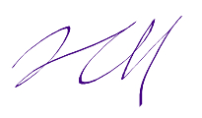
Cr Annalivia Carli Hannan
Mayor

Executive Summary

Moreland’s ‘Children, Young People and Families Plan 2021- 2025’ (the ‘Plan’) aims to improve health, wellbeing and educational outcomes.
The Plan’s vision is that all children, young people and families live in a community where they are healthy, resilient, empowered, safe and belong. This vision sets an ambitious goal to improve outcomes across a range of areas to ensure children and young people have the best start in life, engage in educational opportunities, actively contribute to their community and transition into further training and employment. The Plan is focused on children and young people from birth to adulthood (0-24 years) and their families.
The Plan was informed by extensive community engagement and consultation, evidence-based research and policy analysis which resulted in three outcome areas:
- Outcome 1: Inclusive City and Community
- Outcome 2: Improved Health and Wellbeing
- Outcome 3: Lifelong Learning and Participation.
In each outcome area, there are a series of objectives which provides details of the key focus of work that will be undertaken. The Plan brings together a range of different areas that impact children and young people’s outcomes from early childhood, supporting parents, engagement in education and community to employment pathways. A whole of Council approach and alignment with existing plans and strategies will assist the implementation of the Plan.
Council will work in collaboration with community, partner organisations and state government for improved health, wellbeing and educational outcomes for children, young people and families.

Contents

- Developing the Children, Young People and Families Plan…………………………………………………………………6
- The Plan Summary…………………………………………………………………………………………………………………………………….7
- Council’s Role……………………………………………………………………………………………………………………………………………..8
- An Ecological Systems, Life Course Approach……………………………………………………………………………………..8
- The Evidence Base…………………………………………………………………………………………………………………………………….9
- Children, Young People and Families in Moreland – A Data Snapshot……………………….………………….11
- Community Involvement Shaped the Plan……………..…………………………………………………………………………..12
- Key Emerging Issues………………………………………………………………………………………………………………………………13
- The Plan’s Outcomes and Objectives………………………………………………………………………………………………..…14
- Outcome 1: Inclusive City and Community
- Outcome 2: Improved Health and Wellbeing
- Outcome 3: Lifelong Learning and Participation
- Policy Context…..……………………………………………………………………………………………………………………………………..17
- Implementation, Monitoring and Evaluation……………………………………………………………………………………….18
- References……………………………………………………………………………………………………………………………………………….18

Developing the Children, Young People and Families Plan

The Plan’s vision: A community where children, young people and families are healthy, resilient, empowered, safe and belong.

The ‘Children, Young People and Families Plan 2021-2025’, also known as the ‘Plan’ aims to improve health, wellbeing and educational outcomes of all children, young people and families in Moreland. The Plan explicitly includes families, acknowledging they are central to the lives of children and young people. The Plan details the key outcomes and objectives needed to achieve this goal.
To improve children and young people’s health, wellbeing and educational outcomes, a collective approach is needed. Collaboration between Council and partner organisations will support children to have the best start in life and young people will have opportunities to reach their full potential. The Plan offers opportunities for involvement, collaboration and partnerships, recognising that to improve outcomes, we need to work together.

●    

The Plan’s development marks an important milestone. It is Council’s first integrated Plan to support children, young people and families in Moreland.
There were previously two key strategies which provided direction for programs, services and activities for children and young people; Moreland Early Years Strategy 2016-2020 and Full Potential: A Strategy for Moreland’s Young People. As the Moreland Early Years Strategy 2016-2020 was coming to an end, a new strategy was needed. Insights from Full Potential: A Strategy for Moreland’s Young People will inform the new Plan. Integrating the two strategies into one unified Plan provides opportunities for collaborative planning to improve outcomes for children and young people from birth to adulthood, including a greater focus on transitions between services and educational systems.
There were many stages to developing the Plan. The latest research was analysed to better understand what improves children and young people’s health, wellbeing and educational outcomes. Data and statistics on children and young people were reviewed. The plans and strategies of other Councils and service providers were examined. Most importantly, children, young people and families were asked what they thought was important and what would make a difference to health, wellbeing and educational outcomes. The lived experience and wealth of knowledge of Moreland’s community has shaped the Plan.

The Plan Summary

Moreland Children, Young People and Families Plan
A community where children, young people and families are healthy, resilient, empowered, safe and belong.

Outcomes | 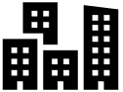  Outcome 1: Inclusive City and Community |   Outcome 2: Improved Health and Wellbeing |   Outcome 3: Lifelong Learning and Participation
Objectives | Objective 1.1: Develop inclusive and accessible activities, programs and services. | Objective 2.1: Increase knowledge of support services and referral pathways. | Objective 3.1: Involve children, young people and families in decision making on matters that impact them.
Objectives | Objective 1.2: Increase opportunities for social cohesion. | Objective 2.2: Increase engagement and participation in preventative health and wellbeing programs. | Objective 3.2: Increase participation in learning and education from birth to adulthood.
Objectives | Objective 1.3: Progress the child-friendly cities and communities initiative. | Objective 2.3: Advocate for increased services to support mental health and resilience. | Objective 3.3: Collaborate with education providers to support quality settings.
Objectives | Objective 1.4: Develop and activate child, young people and family-friendly places and spaces. | Objective 2.4: Provide opportunities for participation in physical and creative activities. | Objective 3.4: Increase opportunities for training and employment pathways.
Objectives | Objective 1.5: Provide infrastructure which meets the needs of the growing population. | Objective 2.5: Collaborate with partner organisations to increase safety in the community and home.
Council’s Role | Plan | Provide | Engage | Collaborate | Advocate

Council’s Role
Council’s role is to plan, provide, engage, collaborate and advocate with and on behalf of children, young people and families.
Council works in many ways to improve children and young people’s outcomes through planning for future services and infrastructure, providing services, engaging with children, young people and families, as well as collaborating and advocating on issues that impact children, young people and families.
Council does this work by:
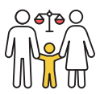  Upholding the rights of children, young people and families | 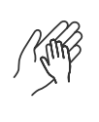  Supporting children, young people and families experiencing vulnerability |   Planning and delivering high quality, universal and targeted services | 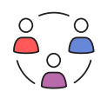  Effective communication and teamwork | 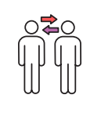  Community engagement and partnerships | 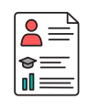  Developing a skilled workforce

An Ecological Systems, Life Course Approach

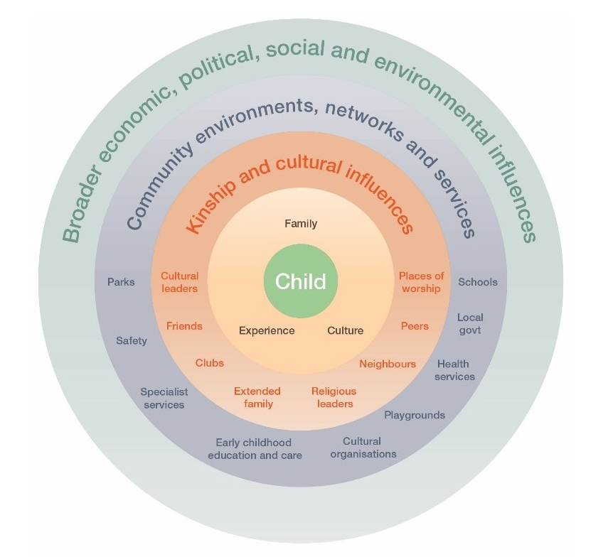
There are two key approaches to improving outcomes which influence the Plan; ecological systems theory and life course approach.
Ecological systems theory recognises that outcomes for children and young people are influenced by a range of factors including family, community, educational institutes and broader economic, political and social influences, also called ‘systems’. Rather than a single factor influencing outcomes for children and young people, it is the influence of these different systems and their collective impact.
At the centre of the ecological model is the child and young person, they are influenced by their immediate family, culture and experiences. The next layer of influence are extended family, peers, cultural leaders and places of worship. The community environments, networks and services system include local neighbourhood amenities such as parks and open space,
Figure 1. Ecological systems model¹

early childhood education and care, schools, health services and how children, young people and families can access and participate in these services. The final system is the social, political, economic and environmental influences which impact children and young people’s outcomes. The Plan recognises how these systems are interrelated and how they collectively impact children and young people.
A life course approach compliments ecological systems theory as it highlights critical periods where additional interventions can be effective. These interventions can be targeted at important stages of life such as transition to primary school and secondary school, transition from school to employment, leaving the parental home and the transition to parenthood. Interventions during these transition points focus on minimising risks and enhancing protective factors and need to be adaptive to the age and development of the child and young person. For example, when a child commences primary school, they are transitioning to a new system and this is also a critical time in their life, this presents an opportunity to strengthen the relationship between the child, family, kindergarten and school to support this transition.
An ecological systems, life course approach is about understanding how different systems interact and support children and young people to move between institutions and services and during critical life stages. The Plan’s outcomes and objectives seek to strengthen these different systems acknowledging a multi-level, collective approach is needed to improve outcomes.
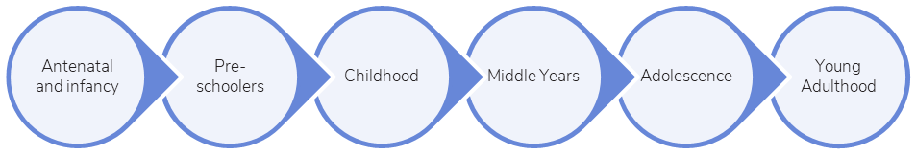
Pre-conception to birth, early childhood | Early education and transition to school | Primary school entry | Transition to secondary school | Secondary school entry to adulthood | Transition to training and employment

Figure 2. Key life stages and intervention opportunities⁴

The Evidence Base

There is a strong evidence base on the factors which make a difference to the lives of children and young people. The general factors which support all children and young people are being loved and safe, material basics such as housing and food, being healthy, learning, participating and having a positive sense of identity and culture. There is also evidence of specific needs at various stages of development in infancy, childhood, middle years, adolescence and young adulthood.

Antenatal and Infancy (0-2 years)
The first 1000 days (from conception to two years of age) is a critical period in early childhood development and presents an opportunity to shape health and wellbeing. The research tells us that during the first 1000 days, children are impacted by family, community and environmental factors. This highlights opportunities to support new parents in their parenting role with a focus on attachment, safety and parental health and wellbeing. It is also important during the first 1000 days to reduce parental stressors through access to support services when needed. There is also evidence that suggests the initiation and duration of breastfeeding decreases the likelihood of obesity and developing allergies in later life. It is also recognised that parents can experience barriers to breastfeeding and all infant feeding methods need to be supported.

Pre-schoolers and childhood (3 to 7 years)
Early childhood is a significant period of development. It is during this time that early life experiences create the foundations for lifelong learning, behaviour and development. Parents have the most important role in influencing children’s outcomes, although other professionals involved in care and education also shape the lives of children. This evidence points to the need for children to access quality learning experiences across early childhood education and care. It is also during this period of childhood that children transition to primary school, providing an opportunity to strengthen the relationship between parents, service providers and schools.

Middle years (8 to 11 years)
The ‘middle years’ are increasingly being recognised as a critical period in childhood where interventions can be made to improve outcomes. A recent Australian study into student wellbeing and learning, found that around 10% of children in the middle years self-reported low wellbeing and over 20% in Years 3 to 5 reported they were bullied across two or all three years. The research suggests interventions can be made within school settings and needs to focus on wellbeing and mental health.

Adolescence (12 to 17 years)
Adolescence is an important time with an increased focus on identity, sexual health and relationships. This can also be a period of increased risk of mental health concerns and alcohol and drug use. This suggests the need for knowledge of available support services and referral pathways for both adolescents and parents. The transition to secondary school also presents an opportunity for additional interventions to strengthen the relationship between young people, schools and parents.

Young Adulthood (18 to 24 years)
Young adulthood is a time of transition, from formal schooling to further training, education and employment. This presents an opportunity to keep young adults engaged and participating in community. During this period, young adults benefit from a range of diverse training and employment pathways to assist transitioning to the workforce.

Children, Young People and Families in Moreland – A Data Snapshot

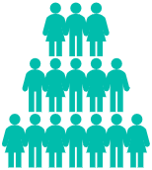  In 2019, the population of people aged 0 to 24 was 55,256. This is forecast to grow to 66,285 in 2036, an increase of 11,019 people aged 0-24. |   One third (33%) of people aged 0 to 24 speak a language other than English at home, with the most common being Arabic, Urdu and Greek. | 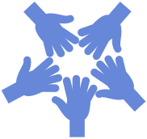  337 people aged 0 to 24 who identified as Aboriginal, Torres Strait Islander or both Aboriginal and Torres Strait Islander in 2016.
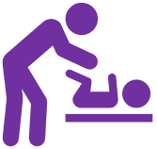  68.4% of children beginning primary school were reported to have attended their 3.5 year Maternal and Child Health check in 2019. | 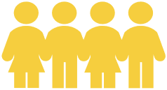  89% of eligible children were participating in 4-year-old Kindergarten in 2019. | 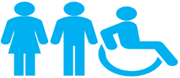  20% of children at school entry were experiencing developmental vulnerability in one or more domains of physical, social, emotional, language and communication in 2018.
  1,626 young people aged 15 to 24 (8.1%) were ‘disengaged’, neither studying or working in 2016. |   Almost 9 out of 10 people (87.5%) aged 18 to 24 had completed Year 12 or equivalent in 2016. |   37% of people aged 0 to 24 years lived in rental dwellings and 10% lived in group housing in 2016.

Community Involvement Shaped the Plan

Moreland’s community was central to creating the Plan. Children, young people, parents, residents and service providers all contributed ideas about what would improve outcomes for children and young people. Involvement and feedback were invited in many ways, from completing the community survey or children’s activity to participating in the workshop, focus group or network conversation.
Over 400 children, young people, parents, community members and partner organisations provided ideas on how children and young people’s outcomes can be improved.

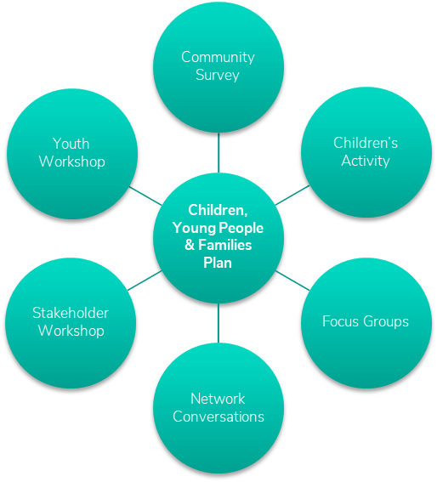
Figure 3. Community engagement activities which informed the Plan

Community engagement activities:
- The community survey provided an opportunity for parents, residents and partner organisations to respond to a range of questions on access to services, local facilities and open questions on how to improve children and young people’s outcomes.
- The children’s activity invited children from 0-12 years to complete a drawing or write a response about what is important to them in their community. This broad theme provided children an opportunity to respond in a diverse way to the central theme of community.
- Focus groups were held with existing groups in Moreland, enabling participants to explore in greater detail questions on how to improve children and young people’s outcomes.
- A series of network conversations provided an opportunity for service providers to respond to broad questions and were held in existing networks in Moreland.
- The youth workshop provided an opportunity for young people, aged 12-24 years of age to participate in a facilitated workshop where four key themes on community, place, resilience and opportunity were discussed.
- The stakeholder workshop included participants from Moreland’s Family and Children’s Services Advisory Committee and the Plan’s Steering Group members. Similar to the youth workshop format, four key themes on community, place, resilience and opportunity were discussed.
The range of activities provided many opportunities for children, young people, families, residents and services providers to have input into the Plan’s development. Following the activities, the responses were analysed for key themes which have informed the Plan’s outcomes and objectives.

Key Emerging Issues

There are four key emerging issues that impact children, young people and families; population growth, equity, impact of the global pandemic and recovery, and climate change.

Population growth
The population of children and young people is increasing in Moreland. As the population grows, additional early years infrastructure will be required to meet the demand for maternal and child health centres and early childhood education and care, such as childcare, kindergarten and playgroups. In particular, the roll-out of funded three-year-old Kindergarten from 2022 will increase pressure on these services. Young people will also be impacted, and multi-use infrastructure may need to be explored to address these gaps.

Equity
Analysis of demographics highlights differences in socio-economic disadvantage and developmental vulnerability. In the Northern suburbs of Moreland, there are areas with higher concentrations of socio-economic disadvantage and higher rates of developmental vulnerability and youth disengagement. An equitable approach to infrastructure, services and programs will be needed to ensure there are opportunities for children, young people and families across Moreland.

Impact of pandemic and recovery
The impact of the global pandemic has had a significant impact on community, with children and young disproportionately vulnerable to its impacts. The pandemic’s effect on mental health and wellbeing, family relationships, disrupted education and lack of employment in common workplaces for young people such as retail and hospitality are still being experienced. Recovery from the pandemic will require tailored interventions and collaborative approaches to meet the needs of children, young people and families.

Climate change
The impact of climate change has a direct influence on the health and wellbeing of children, young people and families. Children are particularly vulnerable to heat stress and increases in thermal temperatures. School grounds where common features include concrete courtyards can also contribute to thermal discomfort and strategies such as urban greening and increasing tree canopy and shade can reduce the impacts. Further action will be needed to address climate change and reduce its impacts on children, young people and families.

The Plan’s Outcomes and Objectives
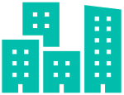

Outcome 1

Inclusive City and Community

Moreland will be an inclusive and accessible city and community where children, young people and families engage in activities, programs and services. There will be respect, acknowledgement and celebration of diverse cultures and identities, recognising the benefits diversity brings to the community. Places and spaces will be accessible and meet the needs of children, young people and families.

What community told us:
Food caravans and live music where we can meet our family friends would be awesome!
6 and 9-year-old, Moreland.
It was hard to get our child into a childcare near us.
Parent,
Brunswick West

Families are extremely diverse, and services need to cater for and be accessible to all.
Parent, Coburg

Objectives
What we will do:
  - Develop inclusive and accessible activities, programs and services.
  - Increase opportunities for social cohesion.
  - Progress the child-friendly cities and communities initiative.
  - Develop and activate child, young people and family-friendly places and spaces.
  - Provide infrastructure which meets the needs of the growing population.

Outcome 2


Improved Health and Wellbeing

Moreland will have increased participation in health and wellbeing programs with a focus on early intervention and prevention. Children, young people and families will have increased knowledge of support services and how to access them. Partner organisations will be supported to strengthen referral pathways and collaborate to improve the health and wellbeing of children, young people and families. Moreland remains committed to the safety of children and young people.

What community told us:

I like playing at the playground with my sister.
4 year old, Fawkner.

I participated in the first Men of Moreland program which was sensational!

Parent,
Coburg North.

Families want the very best for their children, however they are not always sure of where to go, what to do, or what is available.
Service Provider, Moreland.

Objectives
What we will do:
2.1 Increase knowledge of support services and referral pathways.
2.2 Increase engagement and participation in preventative health and wellbeing programs.
2.3 Advocate for increased services to support mental health and resilience.
2.4 Provide opportunities for participation in physical and creative activities.
2.5 Collaborate with partner organisations to increase safety in the community and home.

Outcome 3


Lifelong Learning and Participation
Moreland will have high quality learning opportunities from birth to adulthood. This will include children learning through play in the early years and progressing to formal schooling and beyond. Children, young people and families will be supported when transitioning between education settings such as starting primary school and moving to secondary school. There will be opportunities for young people to engage in further training and pathways to employment. Children and young people will be involved in decisions that impact them. They will be consulted in age-appropriate ways and their opinions will be valued.

What community told us:

I would like to see it easier for teenagers to gain part-time work.
Parent, Pascoe Vale.

It’s been a focus on courses, learning and less on placements and work experience.
Young Person, Moreland.
Girls want to be involved in community [and need to] have access to the same things.
Young Person, Moreland.

Objectives
What we will do:
3.1 Involve children, young people and families in decision making on matters that impact them.
3.2 Increase participation in learning and education from birth to adulthood.
3.3 Collaborate with education providers to support quality settings.
3.4 Increase opportunities for training and employment pathways.

Policy Context

The Plan aligns with a range of International, Federal, State and local Moreland policies which focus on children and young people’s rights and responsibilities, supporting early childhood development, frameworks for improving health and wellbeing and increasing the participation of children and young people in decision making. The policy context has been analysed and alignment with the Plan’s key outcomes is evident (see Figure 4).

 | Policy | Alignment with Plan Outcome
International | United Nations Conventions on the Rights of the Child | 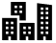
Federal | Belonging, Being and Becoming: The Early Years Learning Framework
Federal | National Youth Policy Framework (currently being finalised – alignment with Interim Report)
Federal | National Action Plan for the Health of Children and Young People 2020-2030
State | Early Childhood Reform Plan: Ready for Schools, Ready for Life
State | Roadmap for Reform: Strong Families, Safe Children
State | Victorian Early Learning and Development Framework
State | Maternal and Child Health Framework
State | Victorian Youth Strategy (under development - alignment with Discussion Paper Outcomes)
Moreland City Council | Council Plan 2021-2025 (under development – alignment with Key Issues Topic Papers)
Moreland City Council | Moreland Human Rights Policy 2016-2026
Plan Outcomes | Inclusive City and Improved Health Lifelong Learning  Community and Wellbeing and Participation
Figure 4. The Plan outcomes and alignment with local, state, federal and international policy

Implementation, Monitoring and Evaluation

An Implementation Plan will be developed with a series of actions to address each objective. These actions will include the timeframe for completion and resources required. The resources may be within existing budgets or require additional resources such as grants to complete.
Monitoring and evaluation of the Plan is an important part of understanding its impact on the three outcomes. A monitoring and evaluation framework with defined measures will be developed. This will include a schedule for undertaking regular reviews of the Plan to monitor its progress and ensure accountability. There will also be annual Council Reports on the actions taken and progress made towards achieving the outcomes.

References

Department of Education and Training 2016, Victorian Early Years Learning and Development Framework, State of Victoria: Melbourne.
Jacob, C., Baird, J., Barker, M., Cooper, C., and Hanson, M 2017, The Importance of a Life Course Approach to Health: Chronic disease risk from preconception through adolescence and adulthood, World Health Organisation: Geneva.
Department of Health 2019, National Action Plan for the Health of Children and Young People 2030-2040 Commonwealth of Australia: Canberra.
Australian Research Alliance for Children and Youth (ARACY) 2014, The Nest action agenda: Improving the wellbeing of Australia’s children and youth while growing our GDP by over 7%, ARACY: Canberra.
Moore, T.G., Arefadib, N., Deery, A. and West, S 2017, The First Thousand Days: An Evidence Paper, Centre for Community Child Health, Murdoch Children’s Research Centre: Parkville.
Ibid.
Ibid.
Ibid.
National Scientific Council on the Developing Child 2007, The Science of Early Childhood Development: Closing the gap between what we know and what we do, Centre on the Developing Child, Harvard University: Cambridge.
Ibid.
The Centre for Adolescent Health 2018, Student Wellbeing, Engagement and Learning across the Middle Years, Murdoch Children’s Research Institute, Commonwealth of Australia: Canberra.
Department of Health 2019, National Action Plan for the Health of Children and Young People 2020-2030, Commonwealth of Australia: Canberra.
Australian Bureau of Statistics 2019, Estimated Resident Population, Regional Population Growth.
Forecast.id 2017, Moreland Population Forecasts 2036.
Australian Bureau of Statistics 2016, Population Census.
Ibid.
Department of Education and Training 2019, Outcomes for Victorian Children at School Entry: Findings from the School Entrant Health Questionnaire Moreland, State of Victoria: Melbourne.
Department of Education and Training 2020, Moreland Kindergarten Participation, Early Years Compact Data Pack (not publicly available).
Australian Early Development Census 2019, Community Profile 2018: Moreland, Commonwealth of Australia: Canberra.
Ibid.
Australian Bureau of Statistics 2016, Population Census.
Ibid.
Department of Premier and Cabinet 2020, What Matters to Young People in Victoria: Victorian youth strategy discussion paper, State of Victoria: Melbourne.
Antoniadis, D., Katsoulas, N & Papanastasiou, D 2020, ‘Thermal Environment of Urban Schoolyards: Current and Future Design with Respect to Children’s Thermal Comfort’, Atmosphere, 11, 1144, pp. 1-26.
United Nations Human Rights 1989, United Nations Convention on the Rights of the Child, UNHCR: Geneva.
Department of Education, Skills and Employment 2007, Belonging, Being and Becoming: the Early Years Learning Framework, Commonwealth of Australia: Canberra.
Department of Health 2019, Youth Taskforce Interim Report, Commonwealth of Australia: Canberra.
Department of Health 2019, National Action Plan for the Health of Children and Young People 2020-2030, Commonwealth of Australia: Canberra.
Department of Education and Training 2017, Early Childhood Reform Plan: Ready for Schools, Ready for Life, State of Victoria: Melbourne.
Department of Health and Human Services 2016, Roadmap for Reform: Strong Families, Safe Children, State of Victoria: Melbourne.
Department of Education and Training 2016, Victorian Early Learning and Development Framework, State of Victoria: Melbourne.
Department of Health and Human Services 2019, Maternal and Child Health Framework, State of Victoria: Melbourne.
Department of Premier and Cabinet 2020, What Matters to Young People in Victoria: Victorian youth strategy discussion paper, State of Victoria: Melbourne.
Moreland City Council 2021, Imagine Moreland: Key issues topic papers, MCC: Coburg.
Moreland City Council 2016, Human Rights Policy 2016-2026: One community, proudly diverse, MCC: Coburg.

