Community Initiative
  - Terms
  - & Conditions
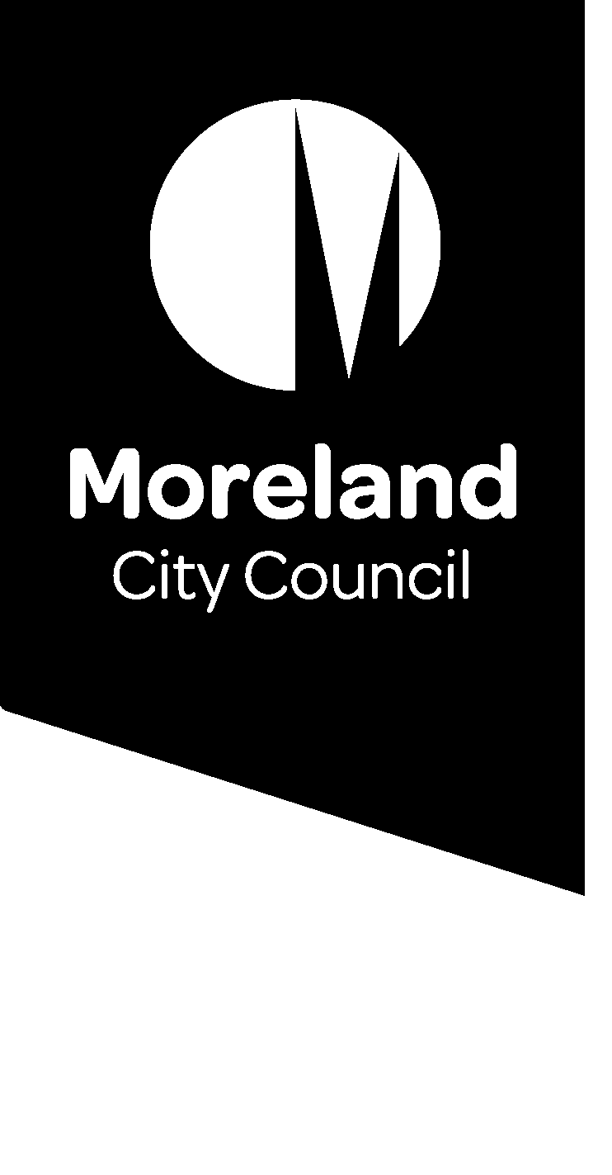
picture

Terms & Conditions
All ideas must be in accordance with the following terms and conditions:
• The idea must demonstrate a strong community benefit.
• The idea must directly align to a strategy of the Council Plan 2021 -2025
• The idea must be for a once-off project or initiative that can be delivered by Council between 1 July 2022 and 30 June 2023.
• The idea must not cost more than $250,000 to implement.
• Moreland City Council has allocated $250,000 for Budget Initiative as part of the 2022/23 budget
• The ideas must be Council-led and delivered with no direct allocation of funds given to community groups, clubs, organisations or commercial business.
• The idea must be lodged by 11.59pm, Sunday 20 February 2022. Applications received after this date and time will not be considered.
• One submission per individual, community group or sporting association is permitted.
• Where there are multiple submissions for the same idea, Council reserves the right to determine which submission will be put forward for consideration.
• If multiple/like submissions for the same idea are received and there is no formal community group/sporting association attached, we will group these submissions and review them as one package.
• As a condition of entry, you agree the name on the application can be made public and promoted on Councils communication channels.

Tips for your application
Demonstrating strong community need
Each application must demonstrate how the idea meets a strong community need.
A simple way of thinking about this is
- What is the problem or opportunity?
- How does it affect or impact the community?
- What difference would your idea make?

Aligning your idea to a strategy or priority of Council Plan 2021 – 2025
Each application must demonstrate how the idea aligns to a strategy of Council Plan 2021 – 2025.

Privacy Collection Statement
Moreland City Council is committed to protecting your privacy in accordance with the Privacy and Data Protection Act 2014 (Vic) and the Health Records Act 2001 (Vic).
The personal information requested on this form is being collected by Moreland City Council for the Community Initiative project and may also be used to update your personal information otherwise held by Council (for example, contact details including email address, phone number). The personal information may be disclosed to Conversations Caravan for the purpose of reporting on the entries received and may also be used by Council for related purposes.
It will not be disclosed to any other external party without your consent, unless required or authorised by law. You can gain access to your personal information you have provided to Moreland City Council and if you wish to alter it, please contact Council’s Privacy Officer via telephone on 9240 1111 or e-mail at Privacyofficer@moreland.vic.gov.au.

