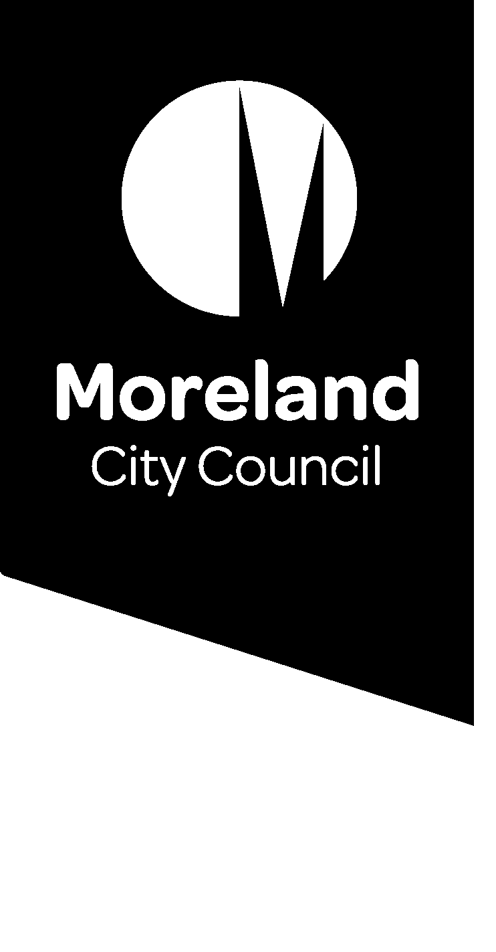
Amendment C180
Information Sheet

Council is proposing to change the zoning of 430-436 Victoria Street and 7 Gardiner Street Brunswick from Industrial 1 Zone to Commercial 2 Zone and apply a Design and Development Overlay and Environmental Audit Overlay to the land

What does Amendment C180 do?
Amendment C180 proposes to rezone the land 430-436 Victoria Street and 7 Gardiner Street Brunswick from Industrial 1 Zone to Commercial 2 Zone. The Commercial 2 Zone will provide an opportunity for a broader range of commercial activity and employment activity to the area whilst at the same time continuing to prohibit residential development.
Amendment C180 also seeks to apply a Design and Development Overlay - Schedule 29 (DDO29) to the sites to guide the scale and design of future development, including:
- Making sure the scale does not dominate or overshadow the adjacent Clifton Park to protect the amenity of the park.
- Directing a landscape design that integrates any new development into the parkland setting and which improves the streetscapes environment
- A design that provides an outlook to the park and adjacent streets to assist in surveillance and safety of the area.
The current industrial zoning permits land uses that may cause land contamination. Amendment C180 also introduces an Environmental Audit Overlay to the rezoned sites to ensure any potentially contaminated land is identified and appropriately managed in accordance with State Government legislation.

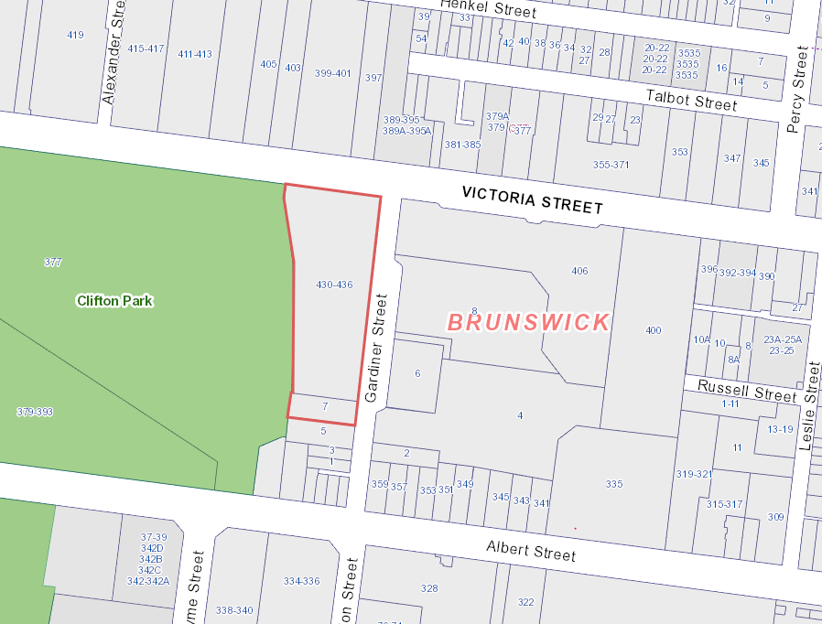
Location Map
Find out more
Visit the Moreland website
You can find detailed information about the proposed changes to the Moreland Planning Scheme and the amendment process.

Speak to an Officer
Council Planning Officers are here to answer your questions about the amendment. If you’d like to discuss how the changes might affect you, please contact the Strategic Planning Unit on 9240 1111.

Frequently Asked Questions
What is the difference between the Industrial 1 and Commercial 2 Zone?
The purpose of the Industrial 1 Zone is to provide a location for manufacturing industry, storage and supply of goods and associated uses.
Whilst industrial uses are still suitable in the Commercial 2 Zone, the Commercial 2 Zone has a stronger focus on commercial activity and will provide commercial areas for offices, bulky goods retailing, other retail uses, and associated business and commercial services.
In both the Industrial 1 Zone and Commercial 2 Zone, residential uses are prohibited.
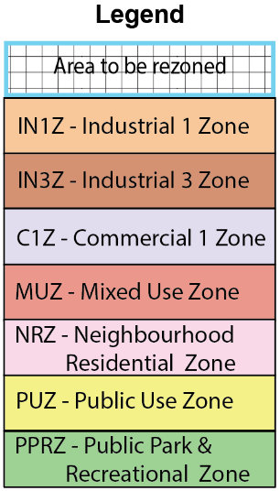
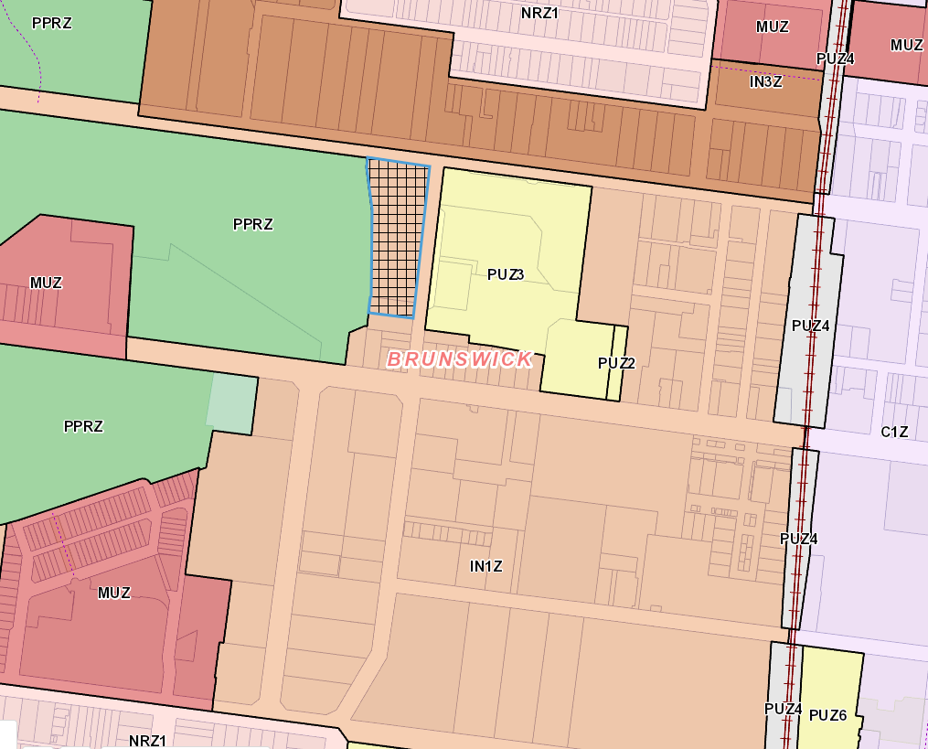
Zoning Map
How will this change impact this Industrial Precinct in Brunswick?
The change in zoning will provide greater flexibility on the type of commercial uses that are permitted on the site whilst still allowing industrial uses and ensuring residential development are prohibited to support this core industrial area in Brunswick.
Does the Amendment align with the Moreland Industrial Land Use Strategy?
The proposed rezoning is consistent with the policy direction of the Moreland Industrial Land Strategy (MILS) that seeks to protect Moreland's core industrial areas as important employment resources that support a broad range of different economic sectors, not just traditional industrial uses.
If the site is rezoned to a Commercial 2 Zone, can an apartment building be built on the site?

A residential use is prohibited in the Commercial 2 Zone. This means that an apartment building, or any building containing a dwelling (such as a single house or row of townhouses) cannot be constructed on the sites.
Amendment C180 is now on public exhibition and you are welcome to make a written submission to Council to express your views. Submissions must be received by Friday, 23 April 2021.
Submissions must be made in writing, giving your name and contact address and clearly stating the grounds on which the amendment is supported or opposed and indicating what changes (if any) should be made.
Submit your views by:
Post:
Strategic Planning
Submission to Amendment C180 Moreland City Council
Locked Bag 10
Moreland VIC 3058
Email: strategicplanning@moreland.vic.gov.au
Please include “Submission to Amendment C180” in the subject line.
Website:
Submissions can be made directly through Council’s website at https://www.moreland.vic.gov.au/planning-building/planning-scheme-amendments/current-amendments/
Make a submission

