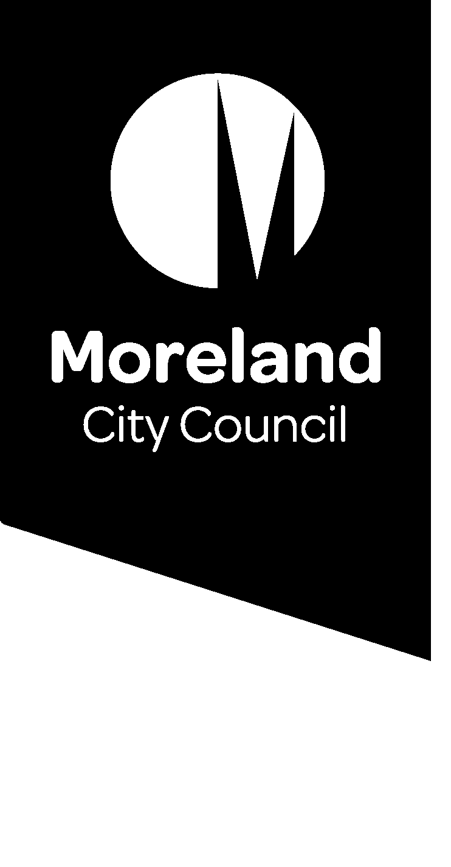

Reducing our waste. Improving our service.

Food waste options for businesses
Do you work in Moreland and want to put your food waste to good use? Read on to find a solution that will work for your business.

Have your say
We are consulting on our waste service, including business waste entitlements, and want to hear from you.
Due to the unique needs of businesses, our household food and garden organics collection service is currently not available to commercial properties.
Get involved by going to conversations.moreland.vic.gov.au/waste or phone 9240 1111.

Compost on-site
- Turn your food scraps into compost at work. There are a range of composting options that you could consider for your business, including compost bins, worm farms and bokashi bins.
- Find tips on how to choose a compost system that is right for your business here: https://www.compostcommunity.com.au/choosing-a-compost-system.html.

Get your food scraps collected by a commercial contractor
- Many commercial operators are available (for a fee) to collect food scraps from your business and turn them into compost.
- Search Planet Ark for a commercial operator that services your area here: https://businessrecycling.com.au/recycle/food-scraps.
- Yarra Valley Water’s ReWaste facility accepts food waste from businesses and turns it into biogas to power the treatment plant that treats our wastewater. Learn more about ReWaste here: http://www.rewaste.com.au/.

Donate your food scraps
- Many community gardens accept food scraps for their communal compost hubs.
  - Find your local compost hubs here: or your nearest community garden here: http://www.moreland.vic.gov.au/environment-bins/garbage-recycling-and-green-waste/composting.
  - Find you nearest community garden on the Moreland Food Gardens Networks website: https://www.morelandfoodgardensnetwork.org/.
- Use ShareWaste, an online platform that connects you with neighbours who will take your food waste for their compost, worm farm or chickens. Find out more about ShareWaste here: http://sharewaste.com/.
Consider an on-site treatment option
- For businesses that produce large volumes of food waste, an on-site organics treatment option might be suitable for you. Options include in-vessel composting units, dehydrators, biogas generators and digesters.
- A range of factors need to be considered to determine the suitability of a preferred treatment option, including installation, funding, maintenance and where the end-product (e.g. compost) will be used.
- For more information refer to the Victorian Food Organics Recycling Guide: https://www2.health.vic.gov.au/hospitals-and-health-services/planning-infrastructure/sustainability/waste/organic-waste.

Use our Commercial Plus service
- Some businesses may be eligible for a food and garden organics bin through our Commercial Plus fee-for-service option.
- To apply or find out more, visit our website: www.moreland.vic.gov.au.

More information
- Victorian Food Organics Recycling Guide: https://www2.health.vic.gov.au/hospitals-and-health-services/planning-infrastructure/sustainability/waste/organic-waste.
- Planet Ark’s Business Recycling – Food Scraps: https://businessrecycling.com.au/recycle/food-scraps.
Or contact Council: 03 9240 1111 or email wasteprojects@moreland.vic.gov.au.

